***SHRI GURU TEGH BAHADUR INSTITUTE OF MANAGEMENT AND INFORMATION TECHNOLOGY***

***MINOR PROJECT***

***FOOD ORDERING WEBSITE***



***Under Supervision of - Submitted by: - Ms. AYEENA BHALLA VAIBHAV AGGARWAL***

***RAGHAV BABBAR***

***GURU GOBIND SINGH INDRAPRASTHA UNIVERSITY***

***(2018-2021)***

DECLARATION

I hereby declare that this project report entitled “ONLINE FOOD ORDERING MANAGEMENT SYSTEM”, **submitted to the Sri Guru Tegh Bahadur Institute of Management & Information Technology, Guru Gobind Singh Indraprastha University** in the partial fulfilment for the award of the Degree of **Bachelor of Computer Application** is an authentic record of work done by me under the guidance of Ms. AYEENA BHALLA. The project has not previously formed the basis for the award of any other degree, Diploma, Associate ship, Fellowship or other title.

**RAGHAV BABBAR**

**BCA 5th SEMESTER**

**06390202018**

CERTIFICATE

This is to certify that **Mr. RAGHAV BABBAR**, University Enrolment Number- **06390202018,** has worked under my supervision to prepare this project report of “ONLINE FOOD ORDERING SYSTEM”. The work embodied in this report is original and is of the standard expected of B.C.A student and has not been submitted in part or full to this or any university for the award of any degree or diploma, He has completed all requirement of guidelines for research project and the work is fit for evaluation.

Date: Signature of HOD (IT): Mr. AMANDEEP SINGH

Place: Delhi

Signature of Guide: Ms. AYEENA BHALLA

ACKNOWLEDGEMENT

The project work in this report is an outcome of continual work and intellectual support from various sources. It is almost impossible to express adequately the debts owed to many persons who have been instrumental in imparting this work a successful status. It is however a matter of great pleasure to express our gratitude and appreciation to all those people who had helped in completion of this project.

I would like to take the opportunity to thank Ms. Ayeena Bhalla for giving me an opportunity to work on this project, which not only has increased our awareness but also has taught us the importance of work, it is because of their guidance, constant encouragement and inspiration that I have been able to accomplish the task of completion this project.

I express our sincere thanks to our project mentor Ms. Ayeena Bhalla a for their invaluable guidance and frequent suggestions during the course of the project. Their suggestions helped me to maintain a good quality of work. I express our deep gratitude to them.

I would also like to thank my project external examiner and all the people who provided me with the facilities being required and conductive conditions for my BCA (3rd YEAR) PROJECT ON **ONLINE FOOD ORDERING SYSTEM.**

ABSTRACT

The purpose of Online Food Ordering System is to automate the existing manual system by the help of computerized equipment’s and full-fledged computer software, fulfilling their requirements, so that their valuable data/information can be stored for a longer period with easy accessing and manipulation of the same. The required software and hardware are easily available and easy to work with.

Online Food Ordering System, as described above, can lead to error free, secure, reliable and fast management system. It can assist the user to concentrate on their other activities rather to concentrate on the record keeping. Thus, it will help organization in better utilization of resources. The organization can maintain computerized records without redundant entries. That means that one need not be distracted by information that is not relevant, while being able to reach the information.

The aim is to automate its existing manual system by the help of computerized equipment’s and full-fledged computer software, fulfilling their requirements, so that their valuable data/information can be stored for a longer period with easy accessing and manipulation of the same. Basically, the project describes how to manage for good performance and better services for the clients.

TABLE OF CONTENT

|  |  |  |  |
| --- | --- | --- | --- |
| **S No** | | **Topic** | **Page No** |
| 1 | | Certificate | - |
| 2 | | Acknowledgements | - |
| 3 | | List of Tables | - |
| 4 | | List of Figures | - |
| 5 | | List of Abbreviations | - |
| 6 | | **Chapter-1: Introduction** | 1-3 |
|  | | 1.1 About Project  1.2 Objective  1.3 Scope  1.4 Features  1.5 Need of the System  1.6 Limitation of Existing System |  |
| 7 | | **Chapter-2: Requirements and Analysis** | 4-7 |
|  | | 2.1 Introduction  2.2 Software requirement Specification  2.3 Functional Requirement of the Project  2.4 Hardware Requirements  2.5 Software Requirements  2.6 Technologies used  2.7 Use Case Diagram |  |
| 8 | **Chapter-3: Software Design** | 8-10 |
|  | 3.1 Introduction  3.2 Module Description   * 1. Data Flow Diagram (DFD)      1. 0-Level      2. 1-Level      3. 2-Level |  |
| 9 | **Chapter-4: Database Design** | 13-16 |
|  | 4.1 Introduction  4.2 Database Fields Specification  4.3 Entity Relationship Diagram |  |
| 10 | **Chapter-5: Testing** | 17-25 |
|  | 5.1 Introduction  5.2 Test Plan  5.3 Conclusions |  |
| 11 | **Chapter-6: Roles and Responsibilities** | 26 |
| 12 | **Chapter-7: Conclusion** | 27 |
|  | 7.1 Future Scope |  |
| 13 | Appendices  -Screenshot  -Codes  -References | 28-52 |

LIST OF TABLES

|  |  |  |
| --- | --- | --- |
| **Table No** | **Title** | **Page No** |
| 1 | Feedback | 13 |
| 2 | Cart | 13 |
| 3 | Contact | 13 |
| 4 | Menu | 14 |
| 5 | Order | 14 |
| 6 | Setprofile | 14 |

LIST OF FIGURES

|  |  |  |
| --- | --- | --- |
| **Figure No** | **Title** | **Page No** |
| 1 | Use Case | 7 |
| 2 | Level “0” DFD | 9 |
| 3 | Level “1” DFD | 10 |
| 5 | Level “2” DFD | 10-12 |
| 4 | E-R Diagram | 16 |
| 17 | Register Page | 28 |
| 18 | Set Profile Page |
| 19 | Login Page | 29 |
| 20 | Home Page (1) |
| 21 | Home Page (2) | 30 |
| 22 | About Page |
| 23 | Menu Page | 31 |
| 24 | Profile Page |
| 25 | Cart Page | 32 |
| 26 | Checkout Page |
| 27 | Payment Page | 33 |
| 28 | Payment Detail Page | 34 |
| 29 | Thank you Page | 35 |
| 30 | Tracking Page (1) |
| 31 | Tracking Page (2) | 36 |
| 32 | Edit Tracking Page (1) |
| 33 | Edit Tracking page (2) | 37 |
| 34 | Add Menu Page |
| 35 | Edit Menu Page | 38 |
| 36 | Frequently Asked Questions Page |
| 37 | Terms and Condition Page | 39 |
| 38 | Feedback Page |
| 39 | Contact Page | 40 |

LIST OF SYMBOLS

|  |  |  |
| --- | --- | --- |
| Entity Symbol | Name | Description |
|  | Relationship | Relationships are associations between or among entities |
| https://images.visual-paradigm.com/docs/vp_user_guide/11/94/2575/2745/uml_use_case_icon_19877.png | [Use Case](https://www.visual-paradigm.com/support/documents/vpuserguide/94/2575/84257_usecasediagr.html#uml-use-case) | Horizontally shaped ovals that represent the different uses that a user might have. |
| https://images.visual-paradigm.com/docs/vp_user_guide/11/94/2575/2745/uml_association_icon_19878.png | Association | A line between actors and use cases. In complex diagrams, it is important to know which actors are associated with which use cases. |
| https://images.visual-paradigm.com/docs/vp_user_guide/11/94/2575/2745/uml_actor_icon_19879.png | [Actor](https://www.visual-paradigm.com/support/documents/vpuserguide/94/2575/84257_usecasediagr.html#uml-actor) | Stick figures that represent the people actually employing the use cases. |
| https://images.visual-paradigm.com/docs/vp_user_guide/11/94/2575/2745/uml_system_icon_19880.png | System | A specific sequence of actions and interactions between actors and the system. A system may also be referred to as a scenario. |
|  | Data Flow | Movement of data between external entities, processes and data stores is represented with an arrow symbol, which indicates the direction of flow. |
|  | Process | An activity that changes or transforms data flows. Since they transform incoming data to outgoing data, all processes must have inputs and outputs on a DFD |
|  | Data Store | A data store does not generate any operations but simply holds data for later access |
| **Entity - ERD Symbol** | Entity | Also known as actors, sources or sinks, and terminators, external entities produce and consume data that flows between the entity and the system being diagrammed. |
| Attribute - ERD Symbol | Attribute | Attributes are characteristics of an entity, a many-to-many relationship, or a one-to-one relationship |

CHAPTER 1

INTRODUCTION

1.1 ABOUT PROJECT

The "Online Food Ordering System" has been developed to override the problems prevailing in the practicing manual system. This software is supported to eliminate and, in some cases, reduce the hardships faced by this existing system. Moreover, this system is designed for the particular need of the company to carry out operations in a smooth and effective manner.

The application is reduced as much as possible to avoid errors while entering the data. It also provides error message while entering invalid data. No formal knowledge is needed for the user to use this system. Thus, by this all it proves it is user-friendly. Online Food Ordering System, as described above, can lead to error free, secure, reliable and fast management system. It can assist the user to concentrate on their other activities rather to concentrate on the record keeping. Thus, it will help organization in better utilization of resources.

Every organization, whether big or small, has challenges to overcome and managing the information of Category, Food Item, Order, Payment, Confirm Order. Every Online Food Ordering System has different Food Item needs; therefore, we design exclusive employee management systems that are adapted to your managerial requirements. This is designed to assist in strategic planning and will help you ensure that your organization is equipped with the right level of information and details for your future goals. Also, for those busy executives who are always on the go, our systems come with remote access features, which will allow you to manage your workforce anytime, at all times. These systems will ultimately allow you to better manage resources.

* 1. OBJECTIVE

The main objective of the Project on Online Food Ordering System is to manage the details of Food Item, Category, Customer, Order, Confirm Order. It manages all the information about Food Item, Payment, Confirm Order, Food Item. The project is totally built at administrative end and thus only the administrator is guaranteed the access. The purpose of the project is to build an application program to reduce the manual work for managing the Food Item, Category, Payment, Customer. It tracks all the details about the Customer, Order, Confirm Order.

* Functionalities provided by Online Food Ordering System are as follows:
* Provides the searching facilities based on various factors. Such as Food Item, Customer, Order, Confirm Order
* Online Food Ordering System also manage the Payment details online for Order details, Confirm Order details, Food Item.
* It tracks all the information of Category, Payment, Order etc
* Manage the information of Category
* Shows the information and description of the Food Item, Customer
* To increase efficiency of managing the Food Item, Category
* It deals with monitoring the information and transactions of Order.
* Manage the information of Food Item
* Editing, adding and updating of Records is improved which results in proper resource management of Food Item data.
* Manage the information of Order
* Integration of all records of Confirm Order.
  1. SCOPE

It may help collecting perfect management in detail. In a very short time, the collection will be obvious, simple and sensible. It will help a person to know the management of passed year perfectly and vividly. It also helps in current all works relative to Online Food Ordering System. It will be also reduced the cost of collecting the management & collection procedure will go on smoothly.

Our project aims at Business process automation, i.e., we have tried to computerize various processes of Online Food Ordering System.

* In computer system the person has to fill the various forms & number of copies of the forms can be easily generated at a time.
* In computer system, it is not necessary to create the manifest but we can directly print it, which saves our time.
* To assist the staff in capturing the effort spent on their respective working areas.
* To utilize resources in an efficient manner by increasing their productivity through automation.
* The system generates types of information that can be used for various purposes.
* It satisfies the user requirement
* Be easy to understand by the user and operator
* Be easy to operate
* Have a good user interface
* Be expandable
* Delivered on schedule within the budget.
  1. FEATURES
* Admin Aspect:
* Add/update/view/delete Menu with their details in database
* View/update tracking
* Logging/log out the system
* View order details
* Visitor:
* View Menu added by admin
* Register
* Contact for query
* User:
* View Menu added by admin
* Give feedbacks
* Contact for query
* Place order
* Payment
* Track
* Logging/log out the system

1.5 NEED OF THE SYSTEM

* System needs to store information about new entry of Food Item.
* System needs to help the internal staff to keep information of Category and find them as per various queries.
* System needs to maintain quantity record.
* System needs to keep the record of Customer.
* System needs to update and delete the record.
* It also needs a security system to prevent data.

1.6 LIMITATION OF EXISTING SYSTEM

In the ongoing modern technology era, everyone likes to get treated by using technology in new ways. In the daily routine requirements, most of the people wants a food service industry to get items at home instead of going away at cafe. Another thing is, time wastage. Everyone will prefer the way that will save their time. As, people go, order and get food from a café counter and wastes their costly time in waiting for food for order.

Solution

There should be a medium that can save all these problems simultaneously. A solution that can save time, make someone able to get food of their choice at their home in less possible time. The Online Food Ordering System provides and solves all these problems. One can easily order food in no time and do their important task instead of waiting at café and get delivered at home and enjoy delicious things.

CHAPTER 2

REQUIREMENTS AND ANALYSIS

2.1 INTRODUCTION

Requirement is determining the needs or conditions to meet for a new or altered product. Requirements analysis is critical to the success of a systems or software project. The requirements should be documented, actionable, measurable, testable, traceable, related to identified business needs or opportunities, and defined to a level of detail sufficient for system design.

2.2 SOFTWARE REQUIREMENT SPECIFICATION

The online pharmacy system should satisfy the following requirements which are discussed below**:**

|  |  |  |  |  |
| --- | --- | --- | --- | --- |
| **No.** | **Requirement** | **Essential or**  **Desirable** | **Description of the Requirement** | **Remarks** |
| 1 | The system should have an ADMIN login. | Essential | Admin portion should appear when admin logins | The login ID and password is stored in database |
| 2 | The system should provide facility of adding, viewing, modifying the menu | Essential | Add menu page should appear when admin wants to add menu. admin should have right to modify /view added menu | Menu will store in database |
| 3 | Registration details should be stored of user | Essential | Registration details of a user should be stored in database. | When new visitor registered himself/herself all information stored in database. |
| 4 | User can view the cart | Essential | User should have right to view the cart | Cart will be store in database |
| 5 | Users should have right to login/logout | Essential | Users have right to login/logout | Users have right to login/logout |
| 6 | User should be able to view order | Essential | User should be able to view order | User have right to view order |
| 7 | The user can give /view Feedback to the admin | Essential | The user has a right to give/view feedback | Feedback should be stored in database, |
| 8 | The user/guest can give Contact to the admin | Essential | The user has a right to give/view contact | Contact should be stored in database, |
| 9 | User should have the right to, make payment | Essential | Users have the right of, make payment | Users have the right to, make payment |
| 10 | User have right to view order status | Essential | User have right to view order status | User have right to view order status |
| 11 | Admin can view/edit the status of order | Essential | Admin can view/edit the status of order | Admin can view/edit the status of order |

2.3 FUNCTIONAL REQUIREMENTS OF THE PROJECT

Required website is for providing info to users about activities. The system should satisfy the following requirements:

* Admin Aspect:
* Add/update/view/delete Menu with their details in database
* View/update tracking
* Logging/log out the system
* View order details
* Visitor:
* View Menu added by admin
* Register
* Contact for query
* User:
* View Menu added by admin
* Give feedbacks
* Contact for query
* Place order
* Payment
* Track
* Logging/log out the system

2.4 HARDWARE REQUIREMENT

* **Processor:** Pentium-4 class processor or Above
* **RAM:** 4GB of RAM or Above
* **Operating System:** Windows XP or Above

2.5 SOFTWARE REQUIREMENT

* **Operating System:** Windows XP or Above
* **Software:** Visual Studio, XAMP

2.6 TECHNOLOGIES USED

* **Front End:** HTML5, CSS, JAVASCRIPT, BOOTSTRAP v4.5.3
* **Language:** Python v3.71 with Django v2.0.13
* **Back End:** MySQL

2.7 USE CASE DIAGRAM

The use case model for any system consists of “use cases”. Use cases represent different ways in which the system can be used by the user. A simple way to find all the use case of a system is to ask the questions “What the user can do using the system?” The use cases partition the system behaviour into transactions such that each transaction performs some useful action from the users’ point of view.

The purpose of the use case to define a piece of coherent behaviour without revealing the internal structure of the system. A use case typically represents a sequence of interaction between the user and the system. These interactions consist of one main line sequence is represent the normal interaction between the user and the system. The use case model is an important analysis and design artifact (task). Use cases can be represented by drawing a use case diagram and writing an accompany text elaborating the drawing.

In the use case diagram, each use case is represented by an ellipse with the name of use case written inside the ellipse. All the ellipses of the system are enclosed with in a rectangle which represents the system boundary. The name of the system being modules appears inside the rectangle. The different users of the system are represented by using stick person icon. The stick person icon is normally referred to as an Actor. The line connecting the actor and the use cases is called the communication relationship. When a stick person icon represents an external system, it is annotated by the stereo type<<external system>>.

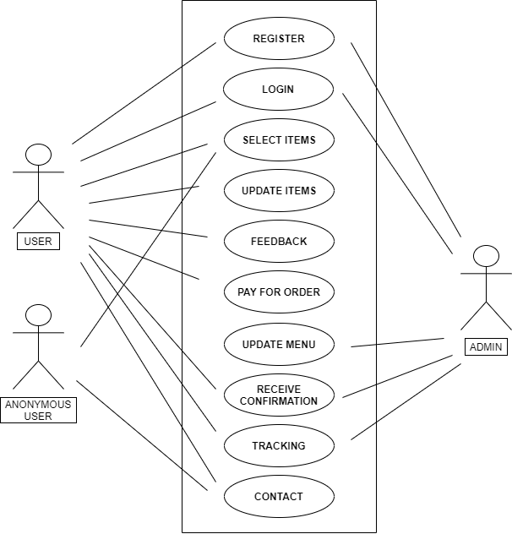

Fig.1 USE CASE DIAGRAM

CHAPTER 3

SOFTWARE DESIGN

3.1 INTRODUCTION

Software design is an engineering process by which we are representing of something that is to be built. It is a blueprint for constructing the software... After making Software Requirement Specification of the project, now we are in position to design the software.

The system design shows how Software will be structured to satisfy the requirements identified during the analysis phase. The design process is a translation of requirements into a description of the software structure, software components, interfaces and data necessary for the implementation phase. The design phase provides a complete blueprint for the implementation activity.

3.2 MODULE DESCRIPTION

,

* User
* Anonymous
* Admin

3.3 DATA FLOW DIAGRAM

A Data Flow Diagram (DFD) is a traditional visual representation of the information flows within a system. A neat and clear DFD can depict the right amount of the system requirement graphically. It can be manual, automated, or a combination of both.

It shows how data enters and leaves the system, what changes the information, and where data is stored.

The objective of a DFD is to show the scope and boundaries of a system as a whole. It may be used as a communication tool between a system analyst and any person who plays a part in the order that acts as a starting point for redesigning a system. The DFD is also called as a data flow graph or bubble chart.

* The following observations about DFDs are essential:

1. All names should be unique. This makes it easier to refer to elements in the DFD.
2. Remember that DFD is not a flow chart. Arrows is a flow chart that represents the order of events; arrows in DFD represents flowing data. A DFD does not involve any order of events.
3. Suppress logical decisions. If we ever have the urge to draw a diamond-shaped box in a DFD, suppress that urge! A diamond-shaped box is used in flow charts to represents decision points with multiple exists paths of which the only one is taken. This implies an ordering of events, which makes no sense in a DFD.
4. Do not become bogged down with details. Defer error conditions and error handling until the end of the analysis.

3.3.1 0-LEVEL DFD

A level 0 DFD is called fundamental system model or context model represents entire software element as a single bubble with input and output data indicating by incoming and outgoing arrows. It is also known as fundamental system model, or context diagram represents the entire software requirement as a single bubble with input and output data denoted by incoming and outgoing arrows. Then the system is decomposed and described as a DFD with multiple bubbles.

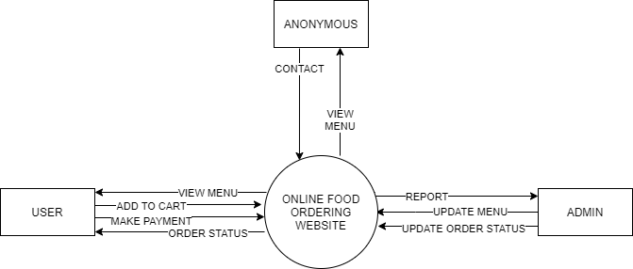

Fig.2 0-Level DFD

3.3.2 1-LEVEL DFD

In 1-level DFD, a context diagram is decomposed into multiple bubbles/processes. In this level, we highlight the main objectives of the system and breakdown the high-level process of 0-level DFD into subprocesses.

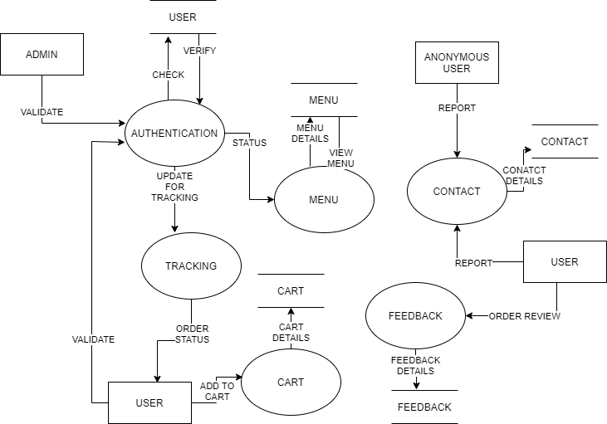

Fig.3 1-Level DFD

3.3.3 2-LEVEL DFD

A level 2 data flow diagram (DFD) offers a more detailed look at the processes that make up an information system than a level 1 DFD does. It can be used to plan or record the specific makeup of a system.

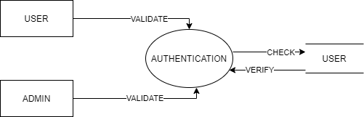

Fig.5.1 Authentication

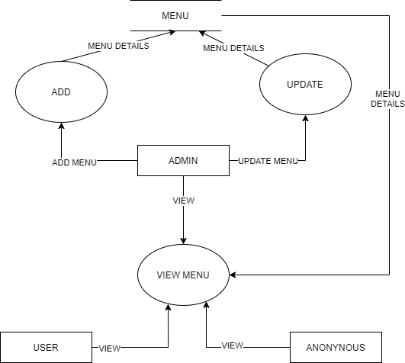

Fig.5.2 Menu

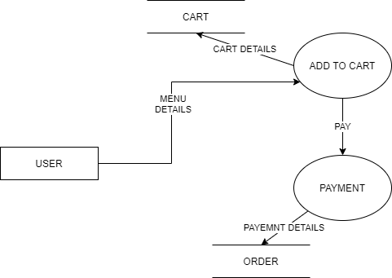

Fig.5.3 Order

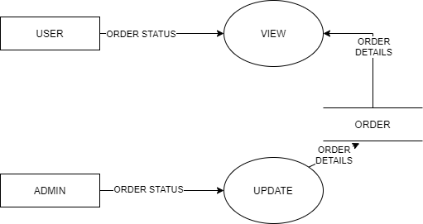

Fig.5.4 Tracking

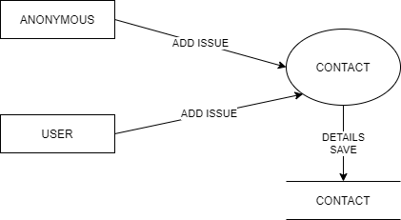

Fig.5.5 Contact

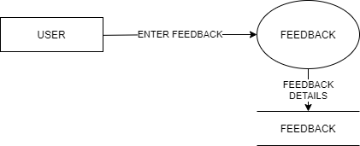

Fig.5.6 Feedback

CHAPTER 4

DATABASE DESIGN

4.1 INTRODUCTION

Database design is the organization of data according to a database model. The designer determines what data must be stored and how the data elements interrelate. With this information, they can begin to fit the data to the database model. Database management system manages the data accordingly. Database design involves classifying data and identifying interrelationships. This theoretical representation of the data is called an ontology. The ontology is the theory behind the database's design.

4.2 DATABASE FIELDS SPECIFICATION

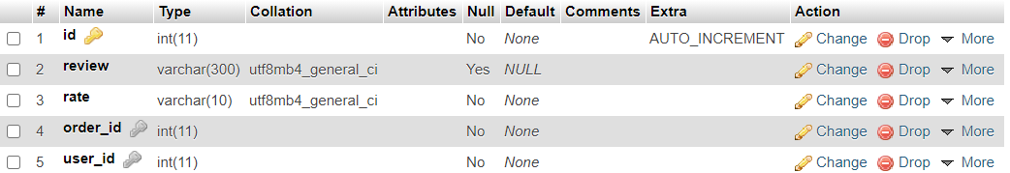

Table 1. Feedback

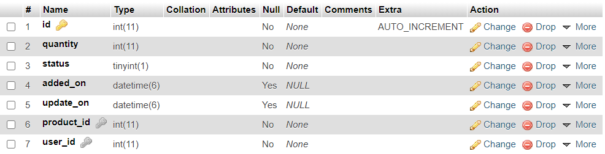

Table 2. Cart

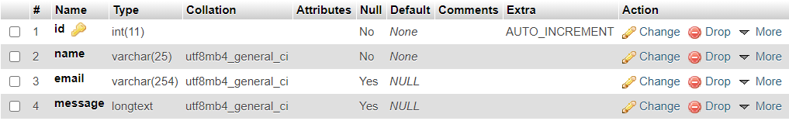

Table 3. Contact

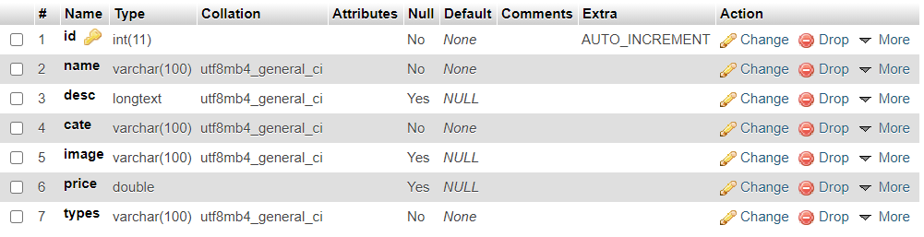

Table 4. Menu

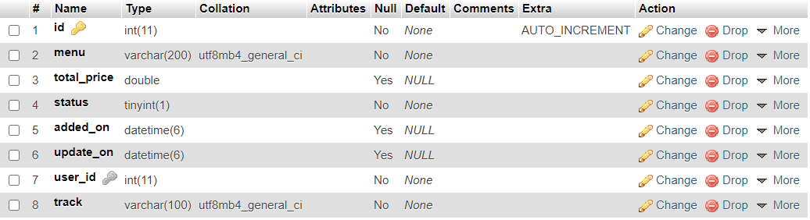

Table 5. Order

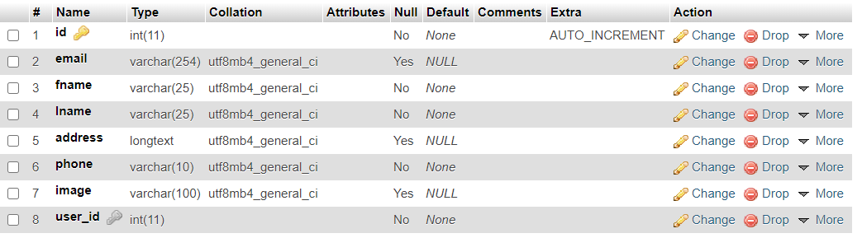

Table 6. Setprofile

4.3 ENTITY RELATIONSHIP DIAGRAM

E-R Model is a popular high level conceptual data model. This model and its variations are frequently used for the conceptual design of database application and many database design tools employ its concept.

A database that confirms to an E-R diagram can be represented by a collecton of tables in the relational system. The mapping of E-R diagram to the entities are:

* Attributes
* Relations
  + Many-to-many
  + Many-to-one
  + One-to-many
  + One-to-one
* Weak entities
* Sub-type and super-type

The entities and their relationshops between them are shown using the following conventions.

* An entity is shown in rectangle.
* A diamond represent the relationship among number of entities.
* The attributes shown as ovals are connected to the entities or relationship by lines.
* Diamond,oval and relationships are labeled.
* Model is an abstraction process that hides super details while highlighting details relation to application at end.
* A data model is a mechanism that provides this abstraction for database application.
* Data modelling is used for representing entities and their relationship in the database.
* Entities are the basic units used in modelling database entities can have concrete existence or constitute ideas or concepts.
* Entity type or entity set is a group of similar objects concern to an organization for which it maintains data,
* Properties are characteristics of an entity also called as attributes.
* A key is a single attribute or combination of 2 or more attributes of an entity set is used to identify one or more instances of the set.
* In relational model we represent the entity by a relation and use tuples to represent an instance of the entity.
* Relationship is used in data modelling to represent in association between an entity set.
* An association between two attributes indicates that the values of the associated attributes are independent.

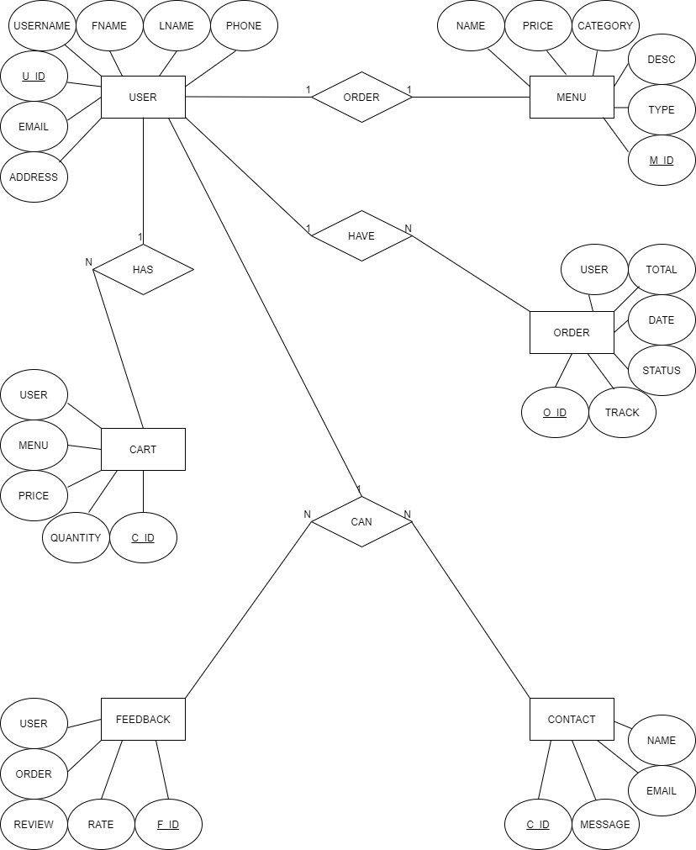

Fig.4 ER DIAGRAM

CHAPTER 5

TESTING

5.1 INTRODUCTION

Executing a program with the intent of finding errors is called testing. Testing is vital to the success of any system. Testing is done at different stages within the development phase. System testing makes a logical assumption that if all parts of the system are correct, the goals will be achieved successfully. Inadequate testing or no testing at all leads to errors that may come up after a long time when correction would be extremely implementation. The testing of the system was done on both artificial and live data. In order to test data test cases are developed.

5.2 TEST PLANS

The test strategy implementation of the project that defines how the testing has been carried out. We followed the Reactive approach to testing. This means that we continued testing each component or module of our project during its creation. However, we are only able to test it completely once the coding and designing part of the project is complete. The testing methodologies in the development process which make sure that the software can successfully operate in multiple environments and across different platforms. We are trying to develop a project which will work on the web and as a mobile application. This will help the end-users to access the platform with ease and flexibility. Also, the offline mode is available for users to access the network anywhere and anytime.

5.2.1 WHITE BOX TESTING

It is a testing approach in which internal structure is known to the tester. It is best suited for a lower level of testing like Unit Testing, Integration testing. White box testing is usually done by testers and developers. It is a structural test of the software. As developers, we realised that testing through the white-box testing procedure is more feasible than black-box testing because we developed the code and therefore have all the knowledge about the internal structure. The features of white-box testing are in favour of the developers. However, when we learn about other kinds of testing such as non-functional testing, we realise that it is also possible to state some information and facts about them based on our project.

5.2.2 Unit Testing

Unit testing is the first level of testing which ensures that the individual components of a piece of software at the code level are functional and work as they were designed. The unit testing was done during the development of the specific components of each module by an individual. This was conducted manually by repeatedly debugging the errors for the proper functionality of the module components. We typically wrote and aimed to execute the tests prior to the software being deployed in front of the evaluators or testers. This testing helped us debug the code at an early stage so that we don’t find errors when we combine all the components of the module together. E.g., Creation and testing of the login page and forgot password page.

5.2.3 Functional Testing

This testing is based on the requirements specified by various stakeholders and incorporates testing to ensure that all the components are working properly.

5.2.4 Integrating Testing

Integration testing is the next step after unit testing. These are then tested as a group through integration testing to ensure whole segments of an application behave as expected. Once all the components were tested, we began combining those components into one module. Manual tests were also conducted for integration. This test enabled us to run all the components one after the other smoothly. For e.g., creation and testing of the homepage and the subpages individually and then combining it to test it for proper functionality.

5.2.5 SYSTEM TESTING

It is executing programs to check logical changes made in it with intention of finding errors. a system is tested for online response, volume of transaction, recovery from failure etc. System testing is done to ensure that the system satisfies all the user requirements.

5.3 TEST CASES

|  |  |  |  |  |
| --- | --- | --- | --- | --- |
| S.No. | Module Name | Test Case No | Test Case Description | Expected Result |
| 1 | Login Validation | TC1 | Username and Password to be verified from the signup credentials | Login Successful on correct credentials |
| 2 | Register Validation | TC2 | Username and Email-ID to be verified from credentials | Register Successful on correct credentials |
|  | | TC3 | Verify the register form when field is blank or submit button click | To enter require detail |
| TC4 | Verify the user can register with different value in Password and Conformation Password | To validate name and password |
| 3 | Menu Validation | TC5 | User should not be able to add menu to cart if not login | User should not be able to add menu in cart |
| 4 | User Validation | TC6 | User should see different page on the basis of customer/Anonymous | Home page should be different if user login |
| 5 | Admin Validation | TC7 | Admin should see different page on the basis of customer/Anonymous | Home page should be different if admin login |
| 6 | Menu Add Module | TC8 | Verify to enter all required Details | To enter require detail |
| 7 | Payment Validation | TC9 | User should able to cancel payment | User should able to cancel payment |
| 8 | Contact Validation | TC10 | Verify the Contact form when field is blank or submit button click | To enter require detail |
| 9 | Feedback Validation | TC11 | Verify the Feedback form when field is blank or submit button click | To enter require detail |

5.4 TEST REPORT

|  |  |  |  |
| --- | --- | --- | --- |
| **S. No.** | **Test Case No.** | **Test Status** | **Test Report** |
| 1 | TC1 | Successful | Fig 6 |
| 2 | TC2 | Successful | Fig 7 |
| 3 | TC3 | Successful | Fig 11 |
| 4 | TC4 | Successful | Fig 12 |
| 5 | TC5 | Successful | Fig 8.1, 8.2 |
| 6 | TC6 | Successful | Fig 9 |
| 7 | TC7 | Successful | Fig 10 |
| 8 | TC8 | Successful | Fig 13 |
| 9 | TC9 | Successful | Fig 14 |
| 10 | TC10 | Successful | Fig 15 |
| 11 | TC11 | Successful | Fig 16 |

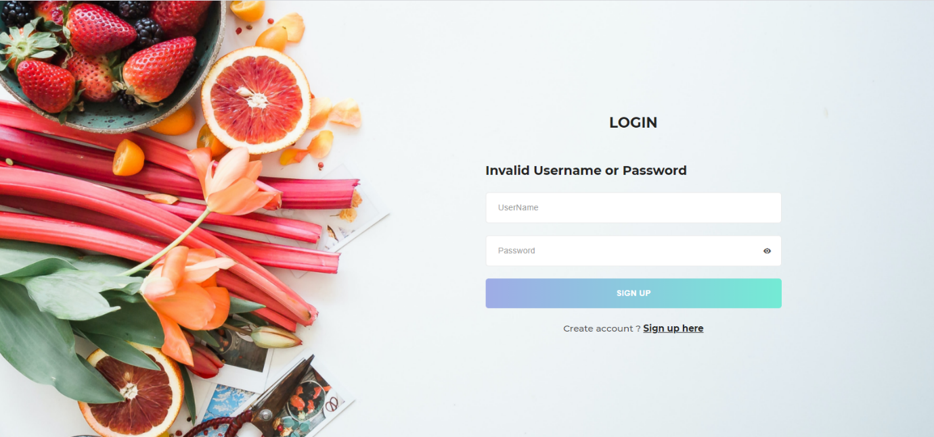

Fig.6 Login Validation

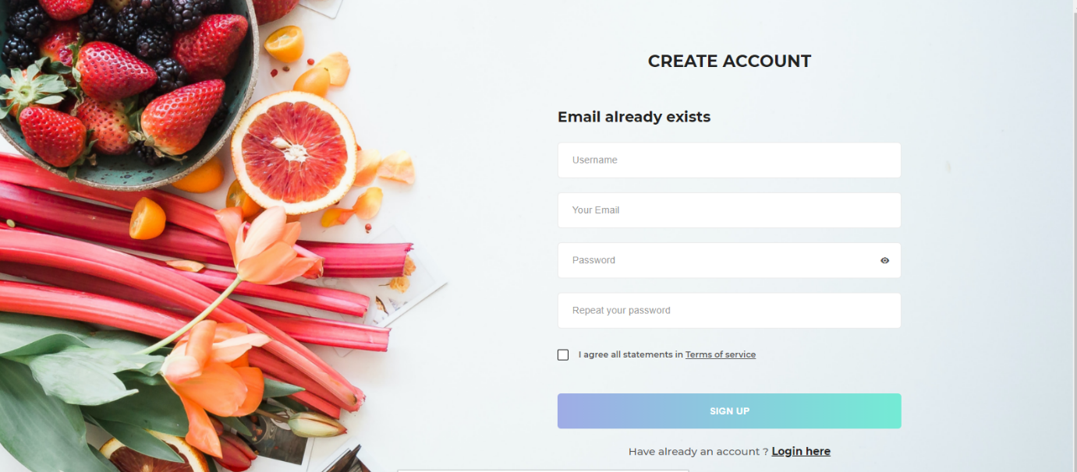

Fig.7 Register Validation

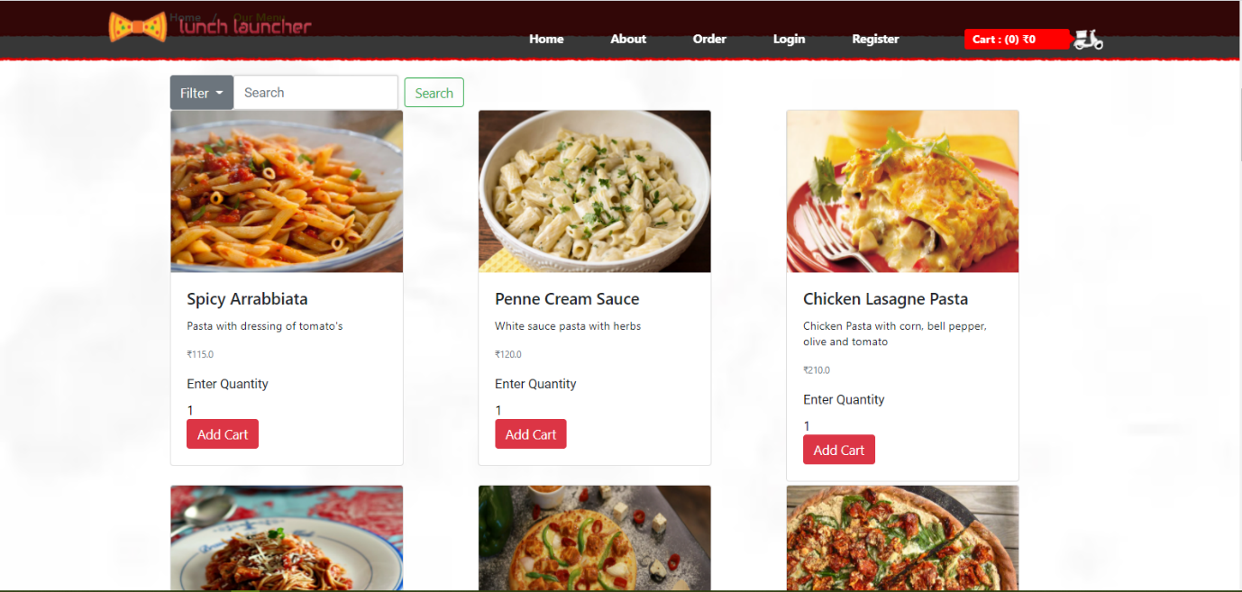

Fig.8.1 Menu Validation

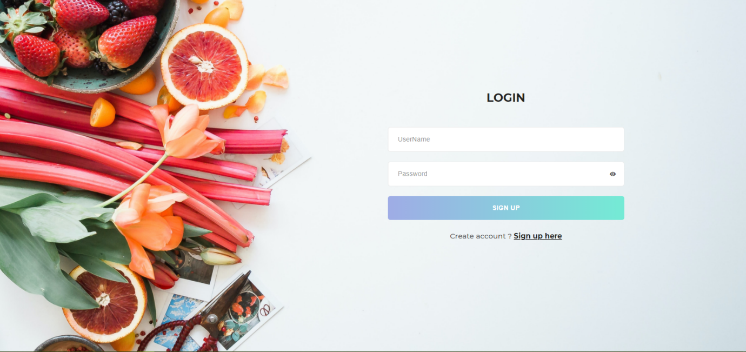

Fig.8.2 Menu Validation

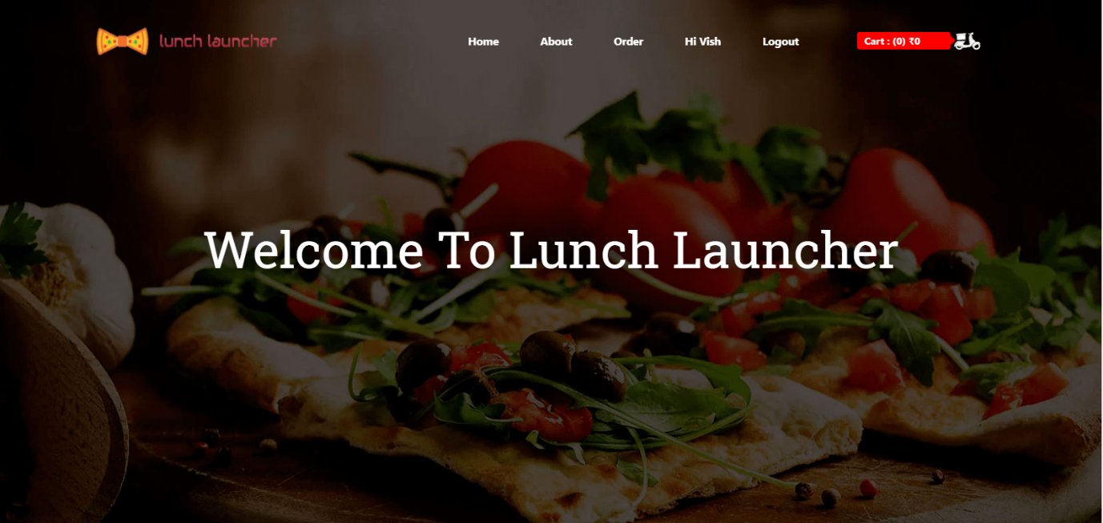

Fig.9 User Validation

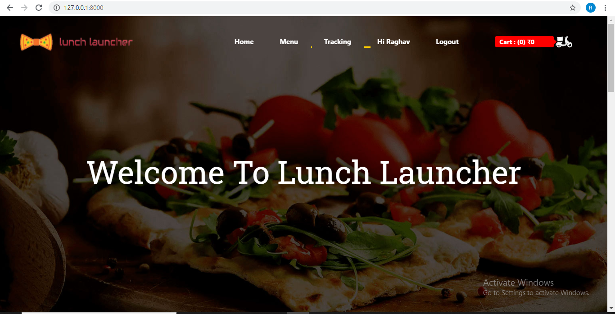

Fig.10 Admin Validation

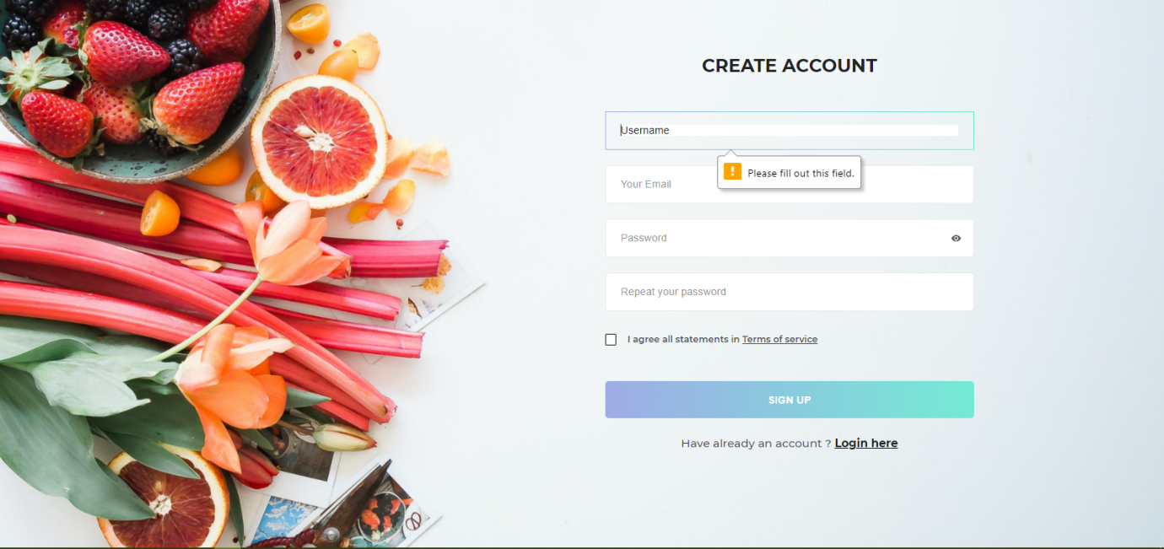

Fig.11 Register Validation

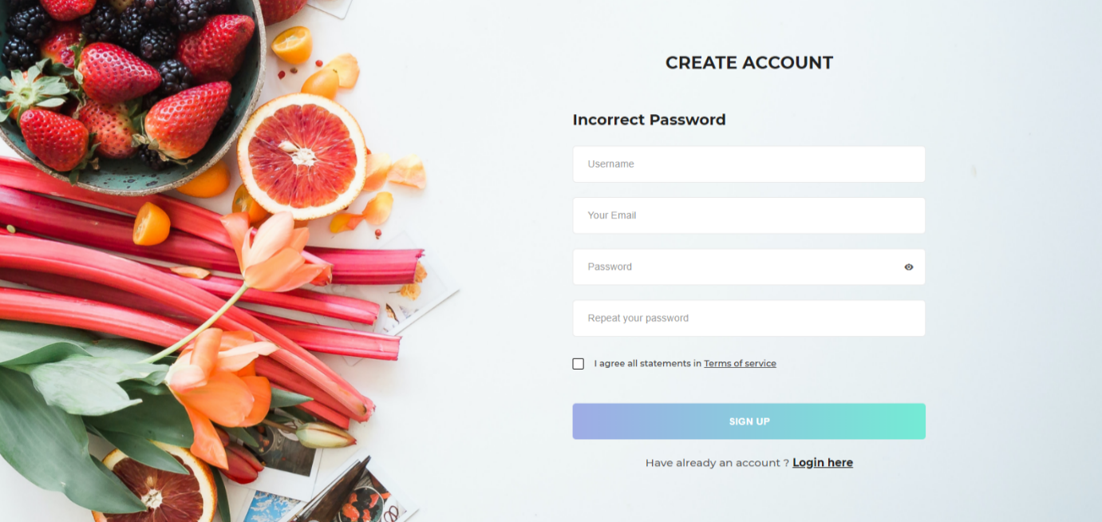

Fig.12 Register Validation

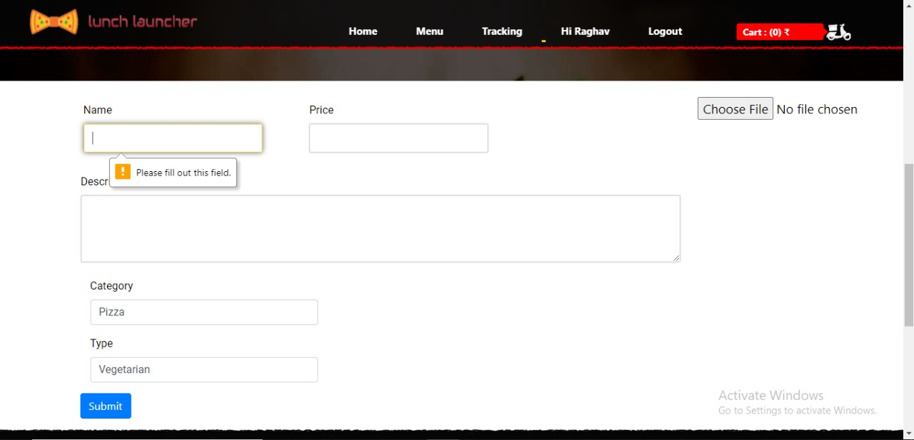

Fig.13 Menu Add Module

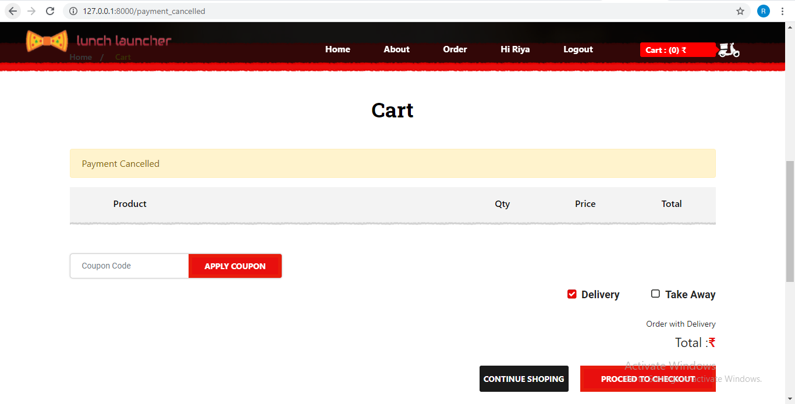

Fig.14 Payment Validation

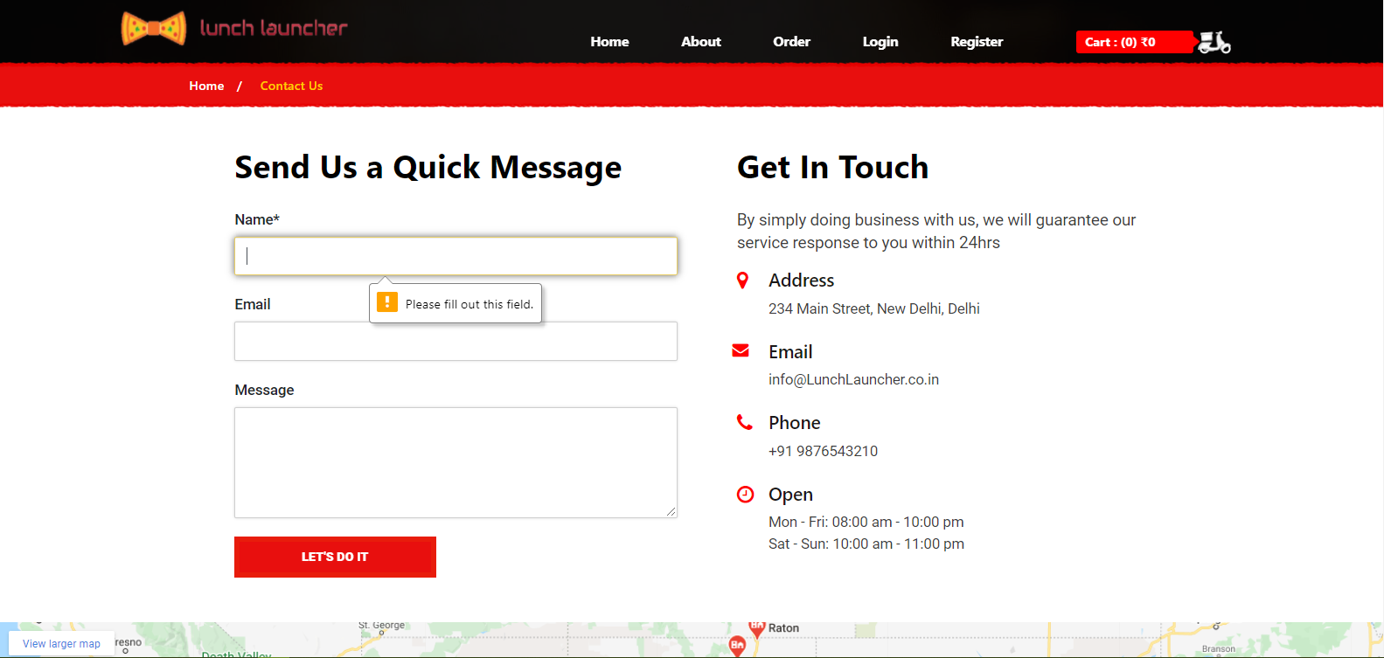

Fig.15 Contact Validation

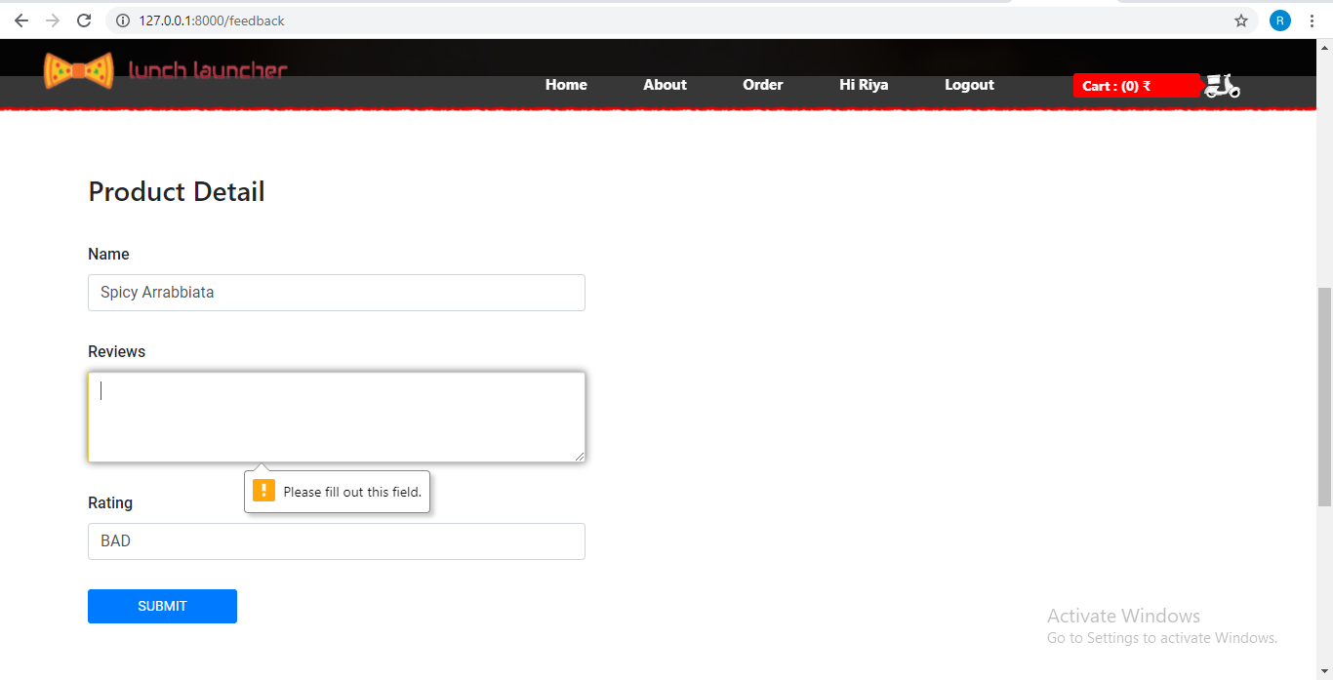

Fig.16 Feedback Validation

CHAPTER 6

ROLES AND RESPONSIBILITIES

6.1 ROLES

While doing my project on Online Food Ordering System, my responsibilities towards my project are:

* I was involved in collection of information related to my project.
* I am responsible for designing few webpages like profile, menu, payment, feedback, contact
* I have used very easy and user-friendly designing mechanism.
* I am responsible for approving the designing tool and database selection.
* Planning and Execution of these pages were done by me.
* I am responsible for database management and managing instances of the above-mentioned modules.

6.1 RESPONSIBILITIES

* Work on definition of development requirements and priorities.
* Data migration.
* Interfaces with other systems.
* Set up and maintenance of security rights and access permission.
* Contributing to technical strategy, policy and procedure.
* Development and operation of technical testing programmes.
* Production of technical documentation to agreed quality standards.
* Reporting on progress/issues to management and users.

CHAPTER 7

CONCLUSION

An online food ordering system is developed where the customers can make an order for the food and avoid the hassles of waiting for the order to be taken by the waiter. Using the application, the end users register online, read the E-menu card and select the food from the e-menu card to order food online. Once the customer selects the required food item the admin will be able to see the results on the screen and start processing the food. This application nullifies the need of a waiter or reduces the workload of the waiter. The advantage is that in a crowded restaurant there will be chances that the waiters are overloaded with orders and they are unable to meet the requirements of the customer in a satisfactory manner. Therefore, by using this application, the users can directly place the order for food online.

In conclusion an online food ordering system is proposed which is useful in small family run restaurants as well as in places like college cafeteria, etc. This project can later be expanded on a larger scale. It is developed for restaurants to simplify their routine managerial and operational task and to improve the dining experience of the clients. This also helps the restaurant owners develop healthy customer relationships by providing reasonably good services. The system also enables the restaurant to know the items available in real time and make changes to their food and beverage inventory based on the orders placed and the

orders completed.

7.1 FUTURE SCOPE

In short, it can be summarized that the future scope of the project circles around maintaining information regarding:

* We can add payment slips in future.
* We can give more advance software for Online Food Ordering System including more facilities.
* We will host the platform on online servers to make it accessible worldwide.
* Integrate multiple load balancers to distribute the loads of the system.
* Create the master and slave database structure to reduce the overload of the database queries.
* Implement the backup mechanism for taking backup of codebase and database on regular basis on different servers.

The above-mentioned points are the enhancements which can be done to increase the applicability and usage of this project. Here we can maintain the records of Food Item and Category. Also, as it can be seen that now-a-days the players are versatile, i.e., so there is a scope for introducing a method to maintain the Online Food Ordering System. Enhancements can be done to maintain all the Food Item, Category, Customer, Order, Confirm Order.

We have left all the options open so that if there is any other future requirement in the system by the user for the enhancement of the system then it is possible to implement them. In the last we would like to thanks all the persons involved in the development of the system directly or indirectly. We hope that the project will serve its purpose for which it is develop there by underlining success of process.

APPENDICES

**SCREENSHOT**

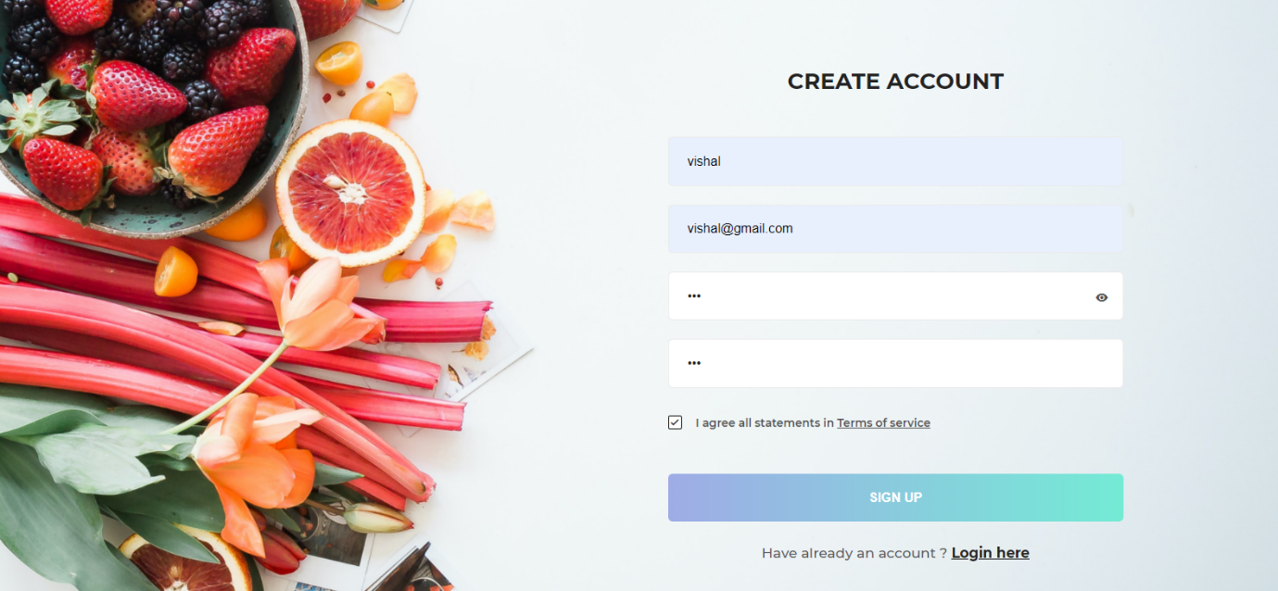

Fig.17 Register Page

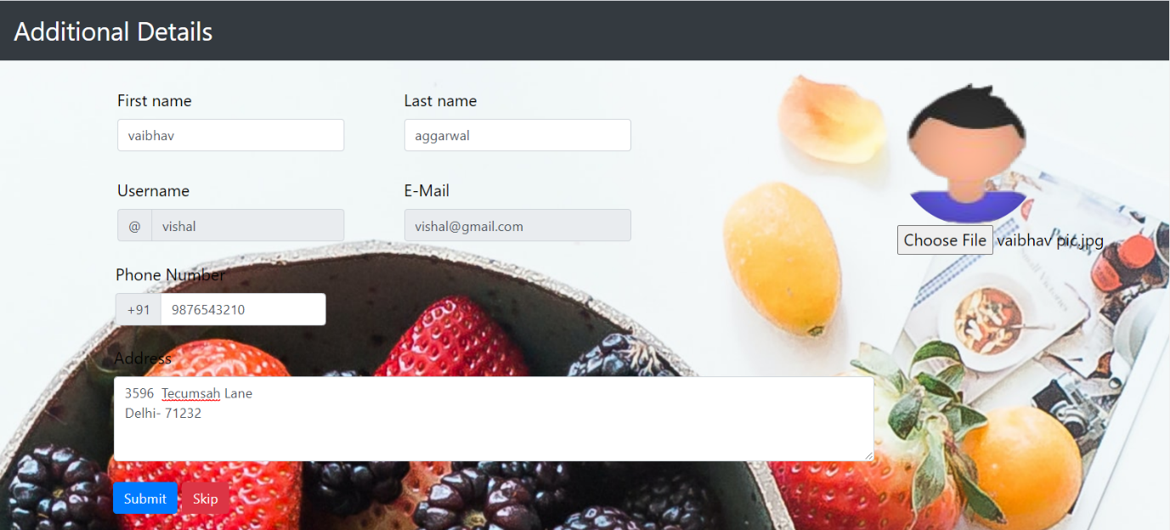

Fig.18 Set Profile Page

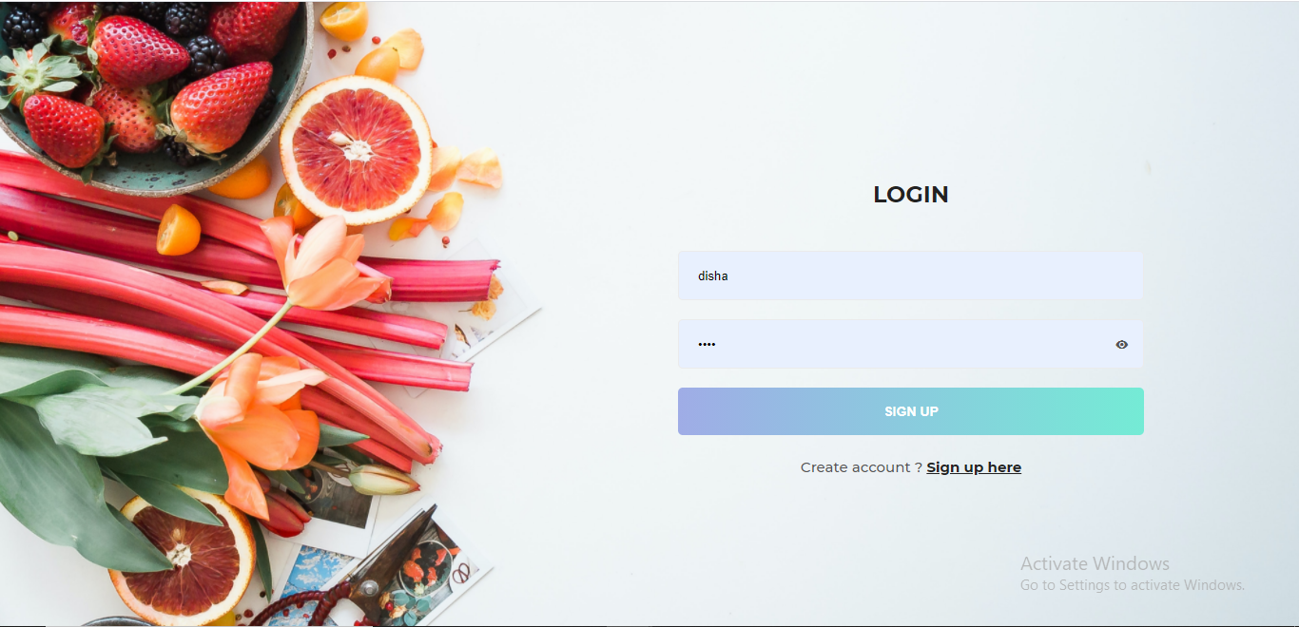

Fig.19 Login Page

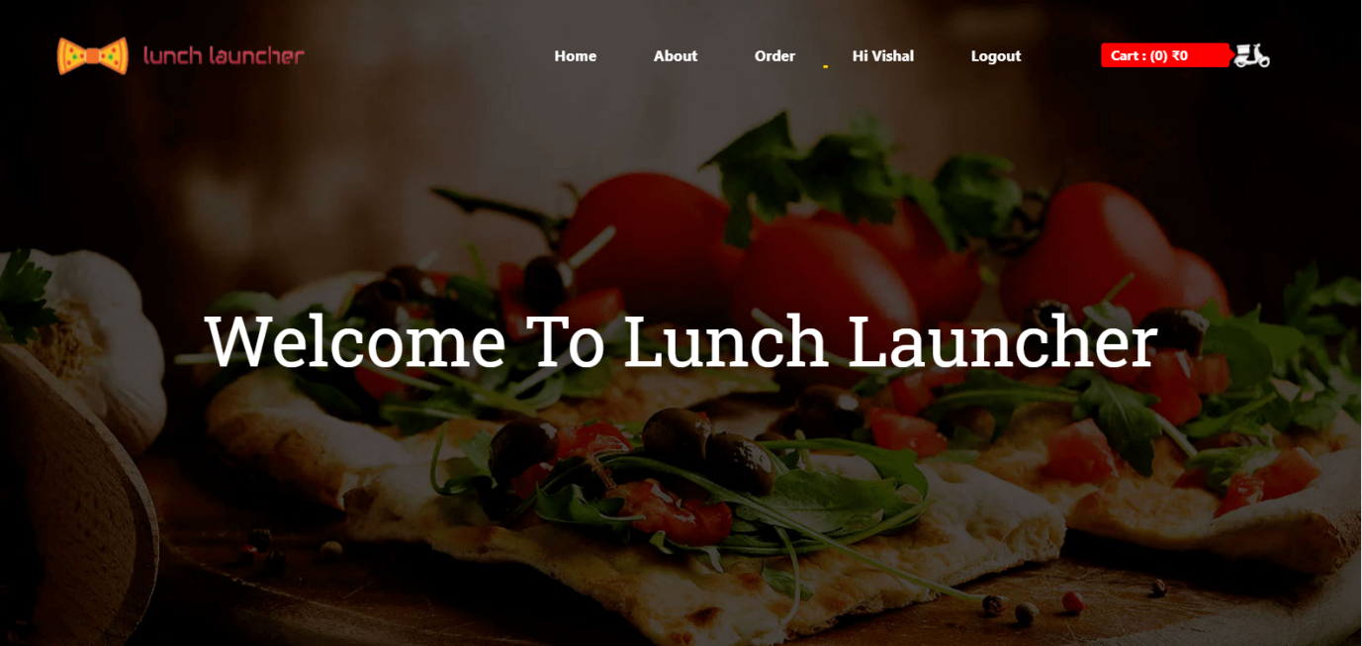

Fig.20 Home Page (1)

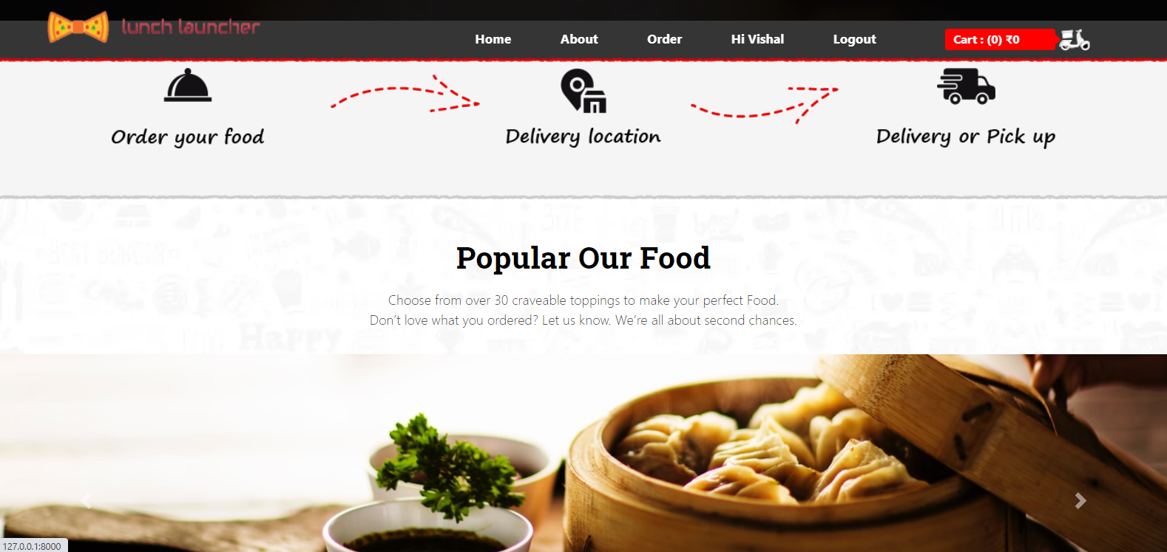

Fig.21 Home Page (2)

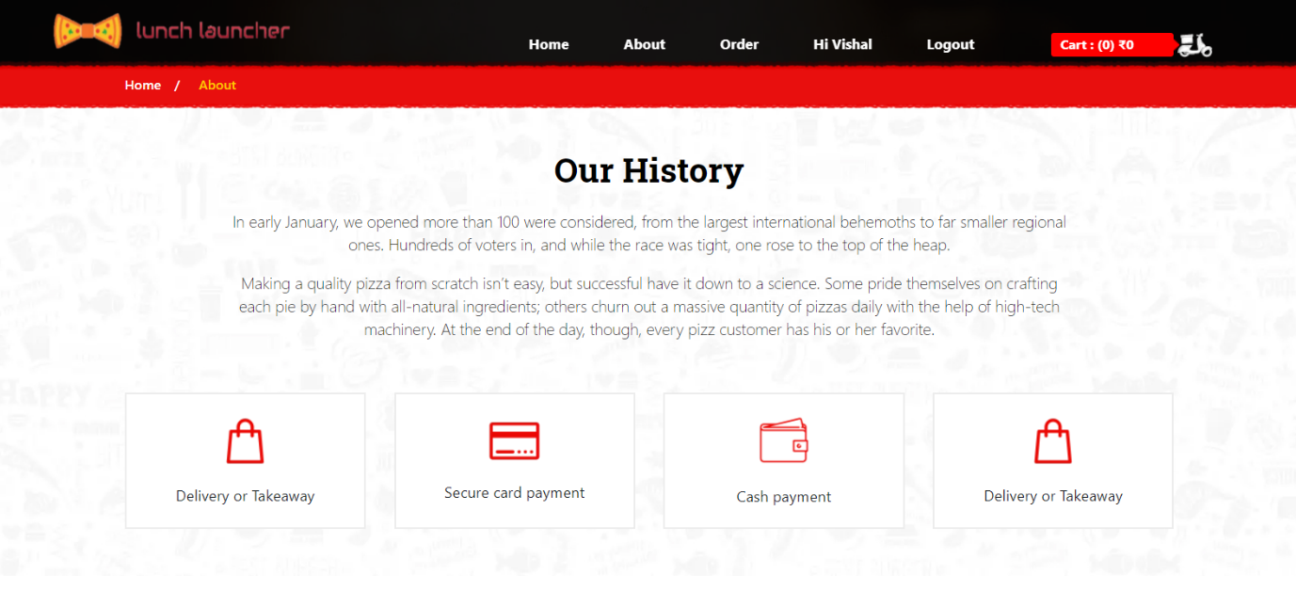

Fig.22 About Page

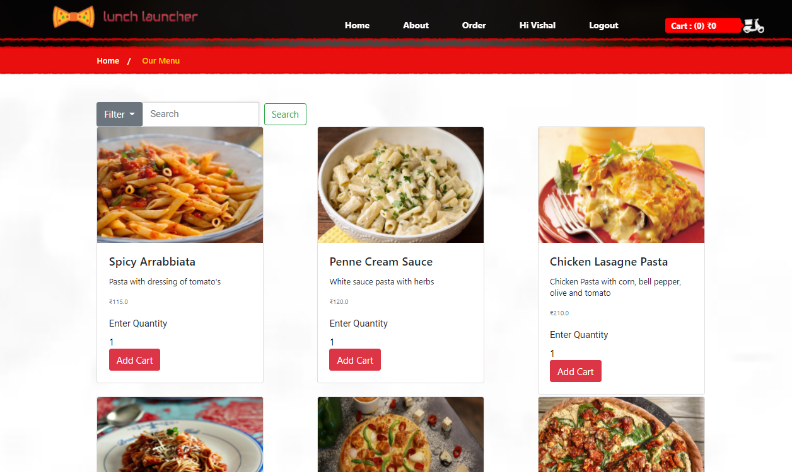

Fig.23 Menu Page

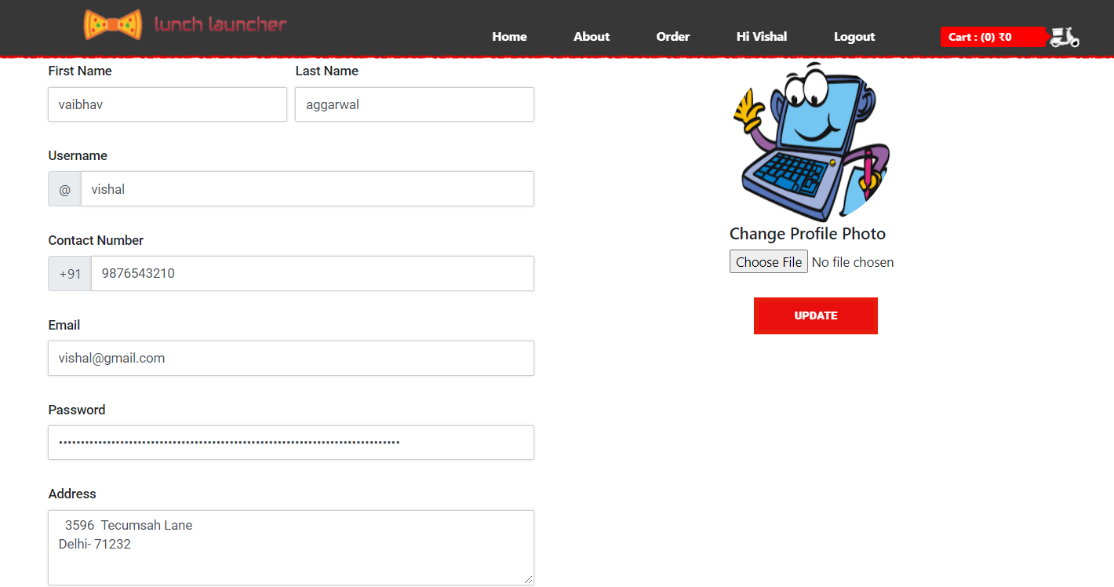

Fig.24 Profile Page

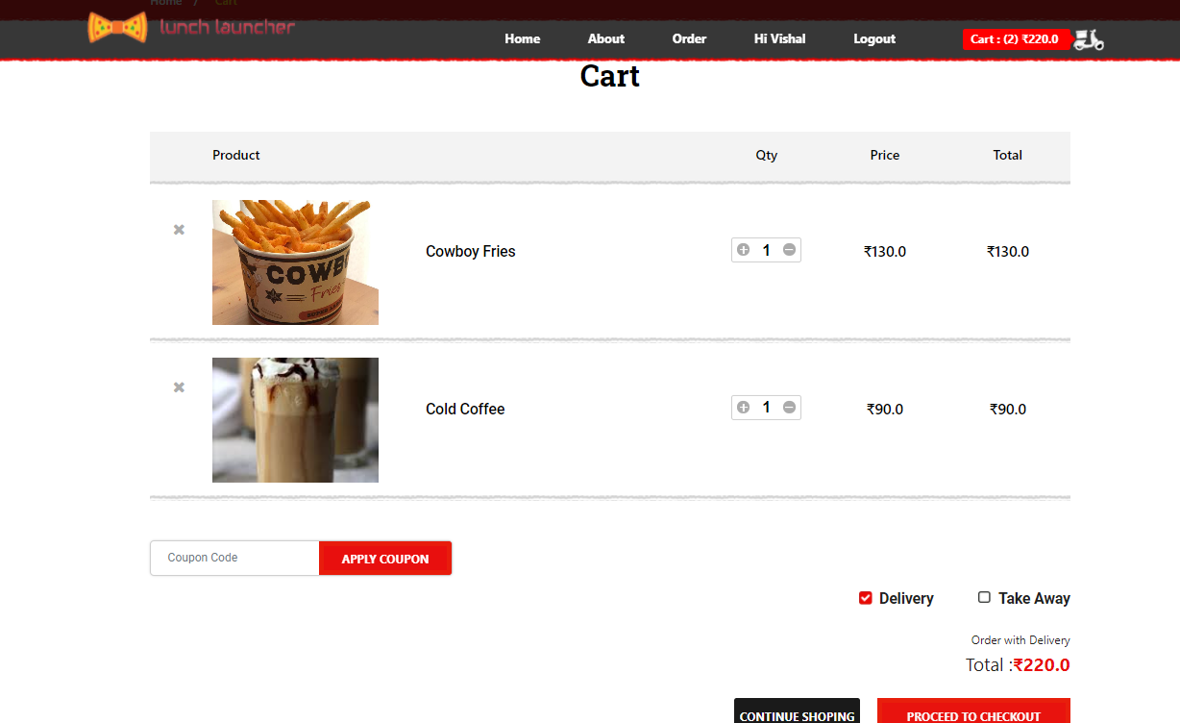

Fig.25 Cart Page

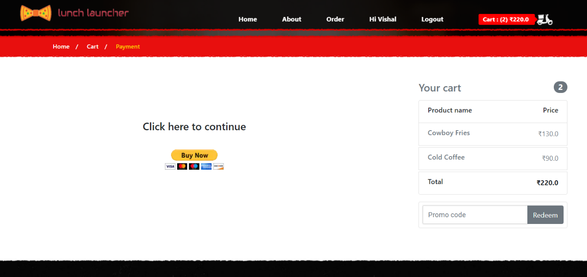

Fig.26 Checkout Page

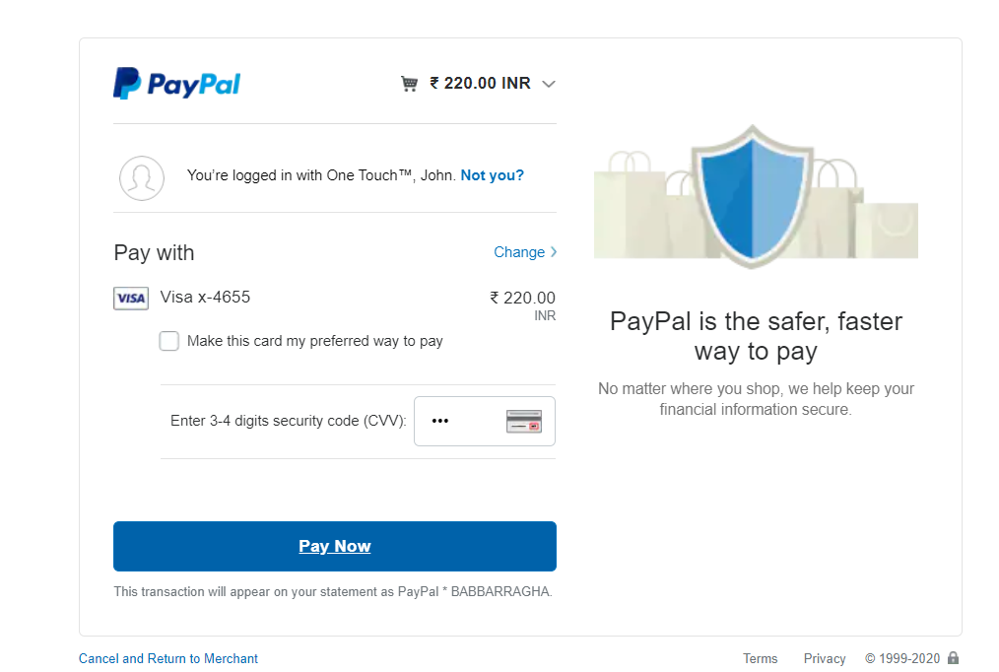

Fig.27 Payment Page

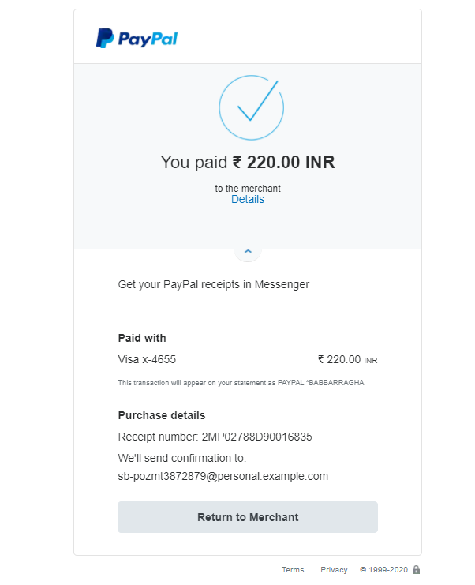

Fig.28 Payment Detail Page

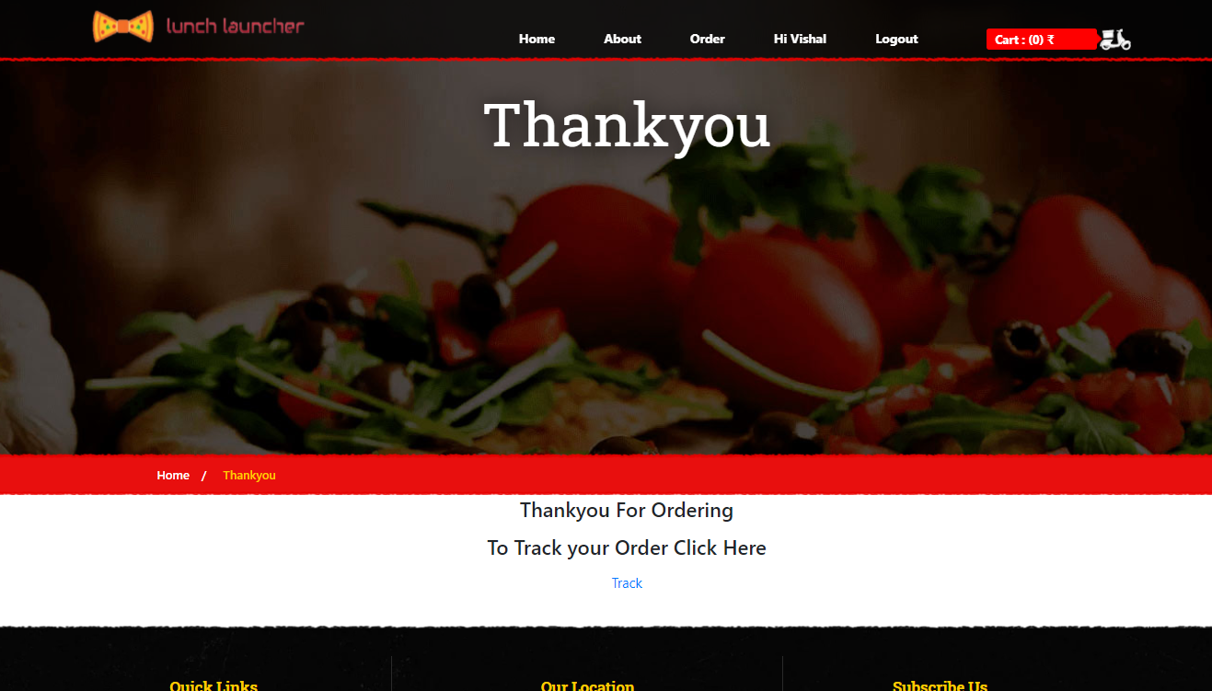

Fig.29 Thank you Page

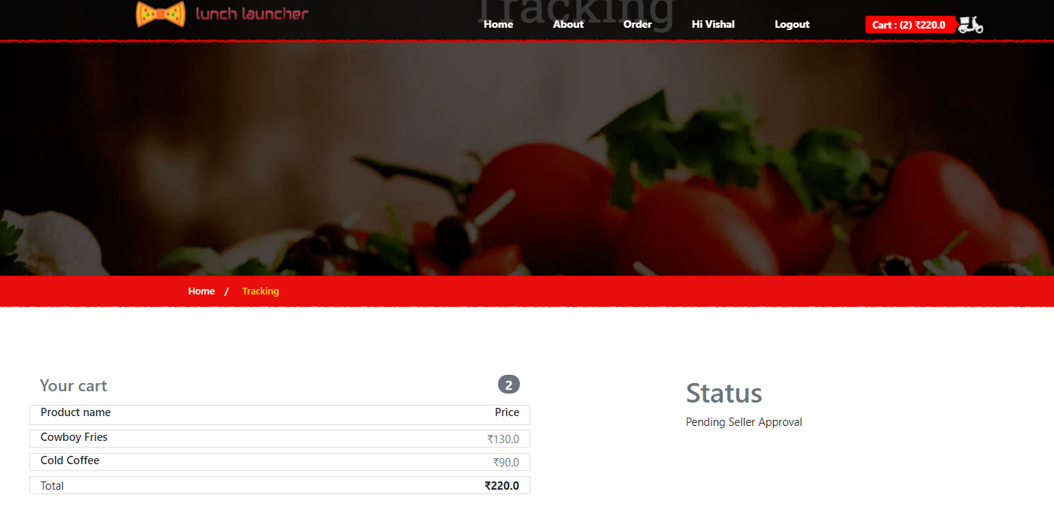

Fig.30 Tracking Page (1)

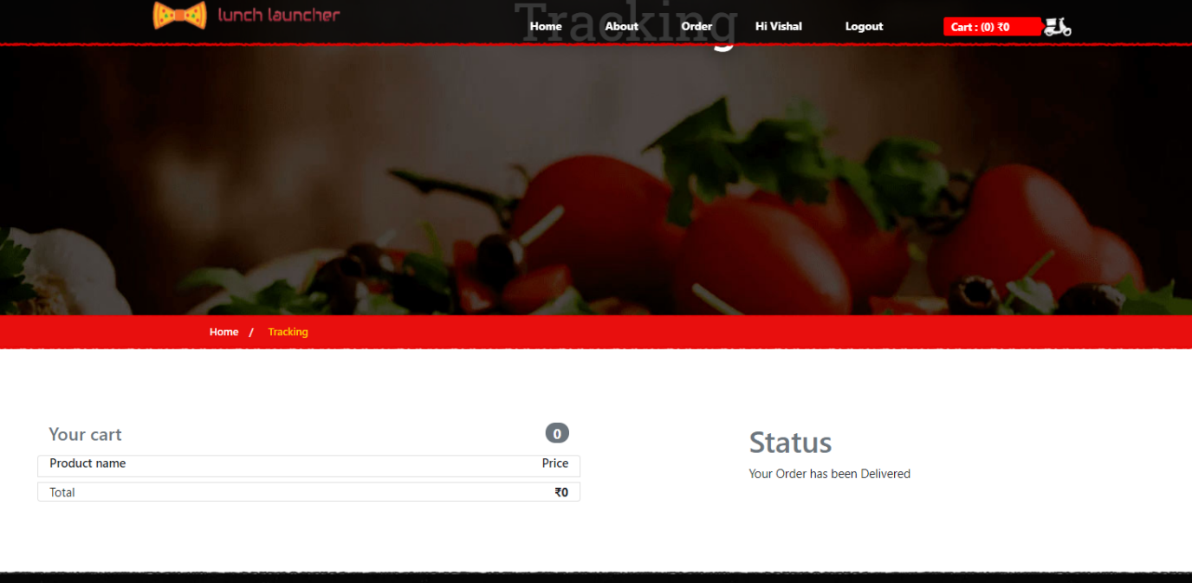

Fig.31 Tracking Page (2)

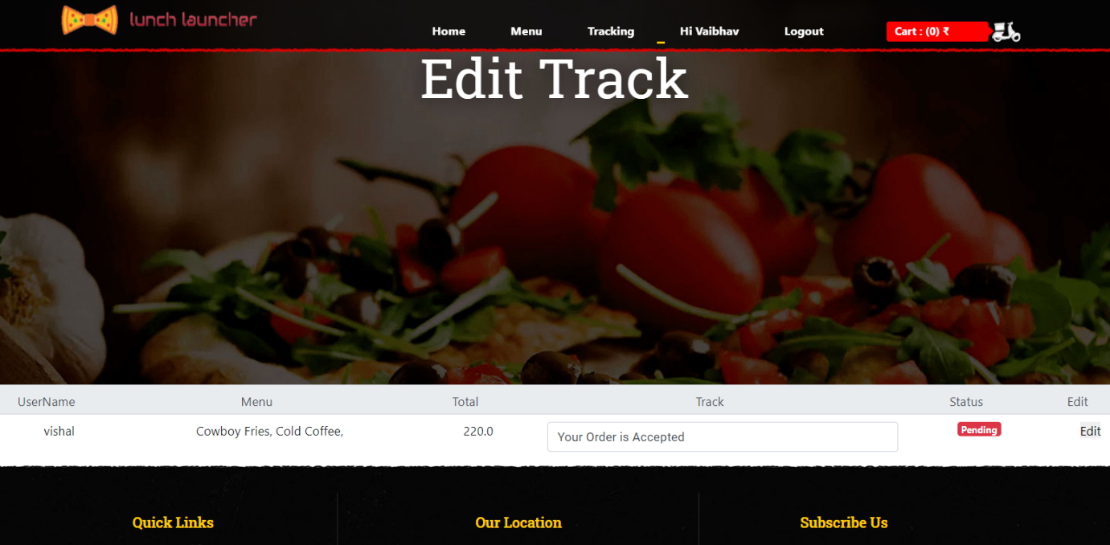

Fig.32 Edit Tracking Page (1)

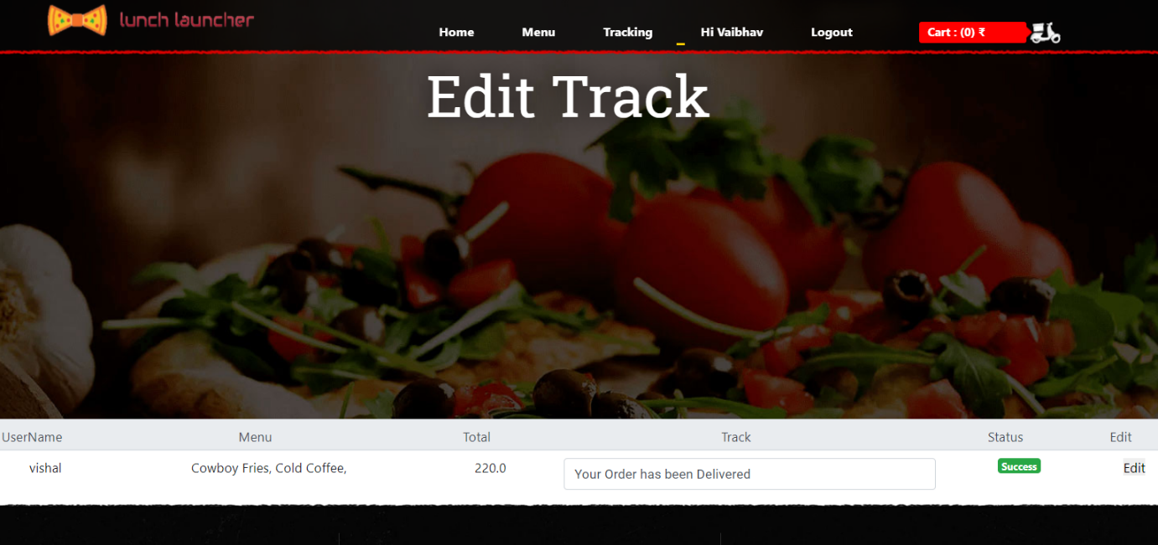

Fig.33 Edit Tracking page (2)

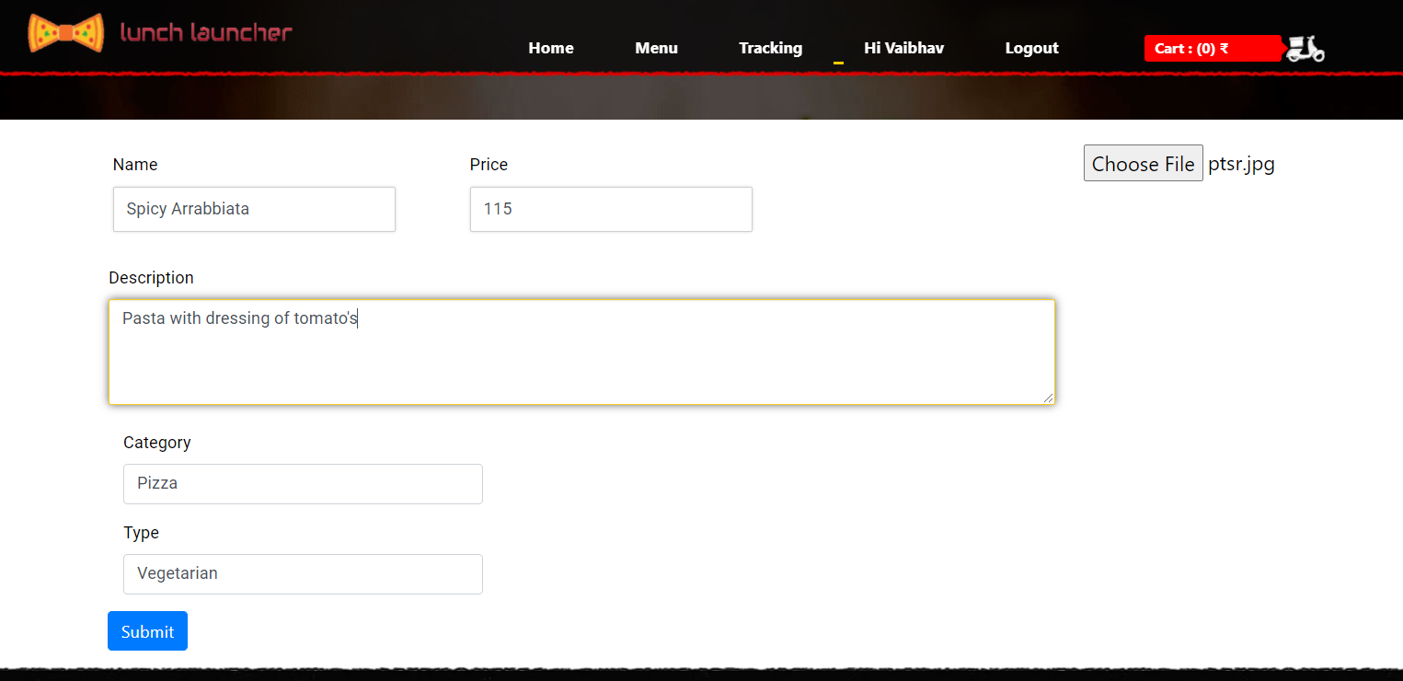

Fig.34 Add Menu Page

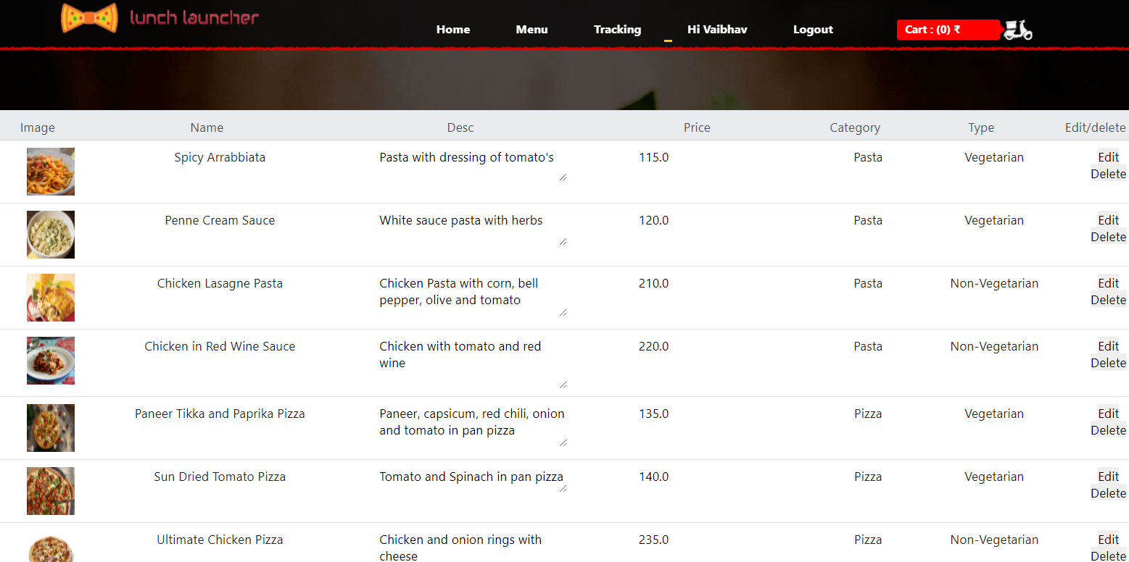

Fig.35 Edit Menu Page

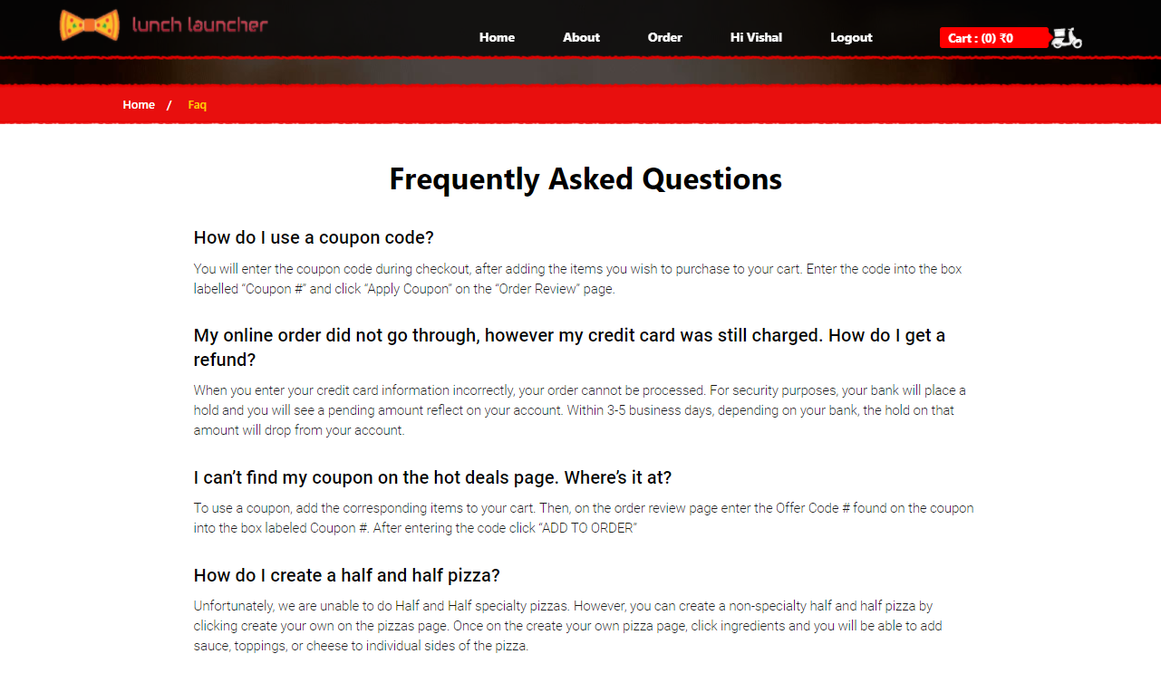

Fig.36 Frequently Asked Questions Page

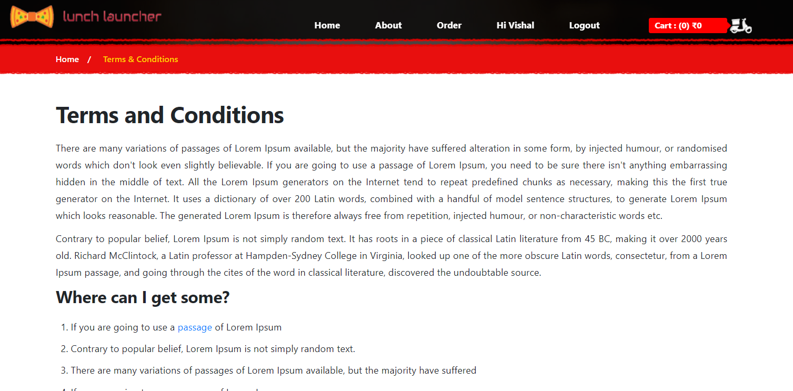

Fig.37 Terms and Condition Page

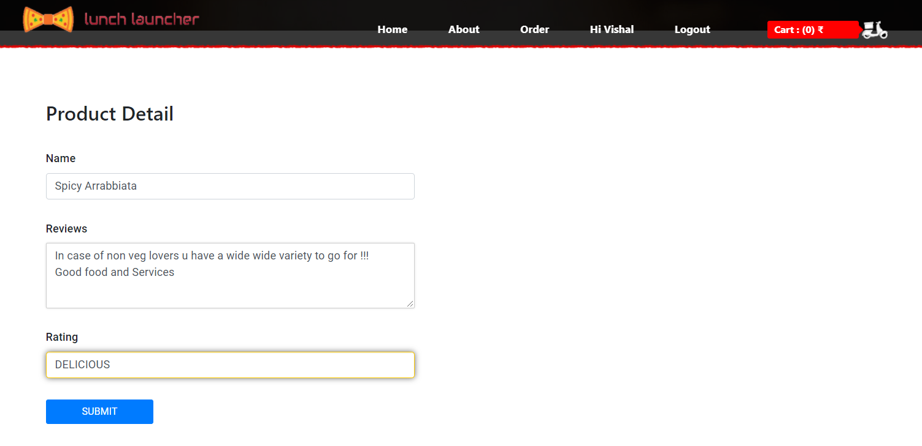

Fig.38 Feedback Page

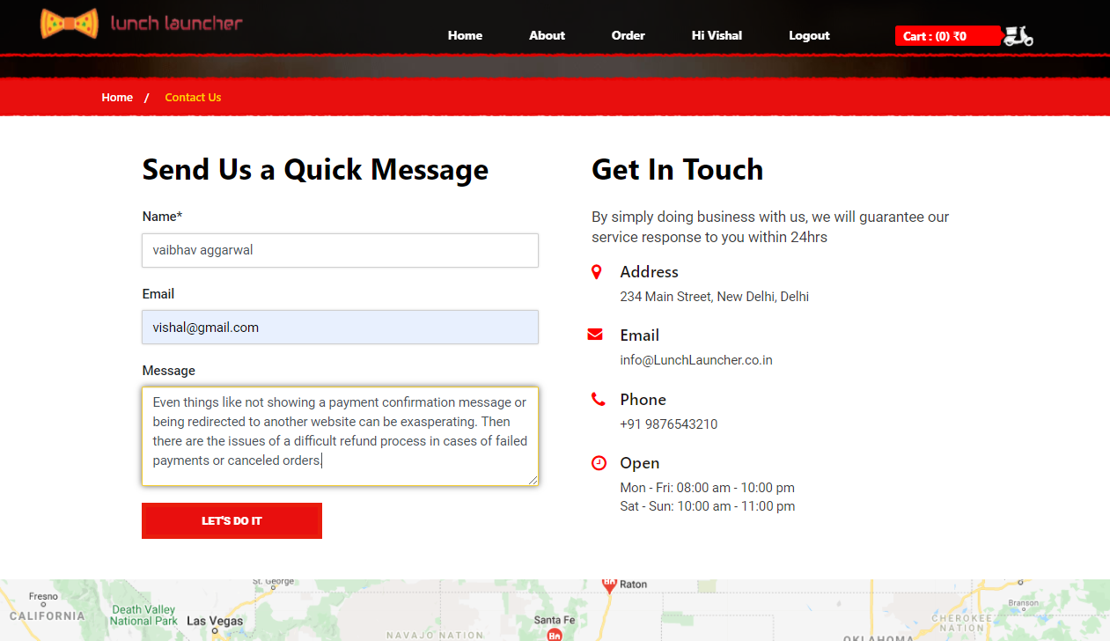

Fig.39 Contact Page

**CODES**

*View.py*

@staff_member_required(login_url='login')

def addmenu(request):

if request.method == 'POST':

name = request.POST.get('name')

price = request.POST.get('price')

desc = request.POST.get('desc')

cate = request.POST.get('cate')

types = request.POST.get('types')

image = request.FILES.get('image')

menu = Menu(name=name, desc=desc, cate=cate,

price=price, types=types, image=image)

menu.save()

return render(request, 'addmenu.html')

@staff_member_required(login_url='login')

def editmenu(request):

menu = Menu.objects.all()

id = request.GET.get('id')

if request.method == "POST":

menu = Menu.objects.get(id=id)

edit = MenuForm(request.POST, request.FILES, instance=menu)

if edit.is_valid():

edit.save()

return render(request, "editmenu.html", {'menus': menu})

@staff_member_required(login_url='login')

def deletemenu(request):

id = request.GET.get('id')

Menu.objects.filter(id=id).delete()

return redirect('editmenu')

def menu(request):

item = Cart.objects.filter(user__id=request.user.id, status=False)

price = 0

total = 0

for i in item:

price = i.product.price*i.quantity

total += price

context = {

'items': item,

'total': total

}

category = request.GET.get('category')

types = request.GET.get('types')

if category:

menus = Menu.get_menu_by_cate(category)

elif types:

menus = Menu.get_menu_by_type(types)

elif request.method == 'POST':

name = request.POST.get('search')

menus = Menu.objects.filter(name__contains=name)

else:

menus = Menu.objects.all()

context['menus']=menus

return render(request, 'menu.html', context)

@login_required(login_url='login')

def cart(request):

context = {}

items = Cart.objects.filter(user__id=request.user.id, status=False)

price = 0

total = 0

for i in items:

price = i.product.price*i.quantity

total += price

context = {

'items': items,

'total': total

}

if request.user.is_authenticated:

if request.method == "POST":

p_id = request.POST.get("p_id")

qty = request.POST.get("qty")

is_exist = Cart.objects.filter(

product_id=p_id, user_id=request.user.id, status=False)

if len(is_exist) > 0:

context["msg"] = "Item Allready Exist in Cart"

context["cls"] = "alert alert-warning"

else:

product = get_object_or_404(Menu, id=p_id)

usr = get_object_or_404(User, id=request.user.id)

c = Cart(user=usr, product=product, quantity=qty)

c.save()

return redirect('menu')

else:

context["error"] = "Login to View Your Cart"

return render(request, 'cart.html', context)

@login_required(login_url='login')

def editcart(request, id):

if request.method == "POST":

cart = Cart.objects.get(id=id, status=False)

edit = CartForm(request.POST, instance=cart)

if edit.is_valid():

Edit = edit.save(commit=False)

Edit.user = request.user

Edit.save()

return redirect('cart')

@login_required(login_url='login')

def deletecart(request):

id = request.GET.get("id")

Cart.objects.filter(id=id, status=False).delete()

return redirect('cart')

@login_required(login_url='login')

def payment(request):

item=Cart.objects.filter(user__id=request.user.id,status=False)

price=0

total=0

menu=[]

inv=""

for i in item:

price=i.product.price*i.quantity

total+=float(price)

menu=str(i.product.name)

inv+=str(i.id)

paypal_dict = {

'business': settings.PAYPAL_RECEIVER_EMAIL,

'amount': str(total),

'item_name': menu,

'invoice': inv,

'currency_code': 'INR',

'notify_url': 'http://{}{}'.format("127.0.0.1:8000",

reverse('paypal-ipn')),

'return_url': 'http://{}{}'.format('127.0.0.1:8000',

reverse('payment_done')),

'cancel_return': 'http://{}{}'.format('127.0.0.1:8000',

reverse('payment_cancelled')),

}

form = PayPalPaymentsForm(initial=paypal_dict)

return render(request, 'payment.html', {'form': form, 'total':total, 'items':item})

#return render(request, 'payment.html',{'total':total})

@csrf_exempt

def payment_done(request):

item=Cart.objects.filter(user__id=request.user.id,status=False)

user=request.user

price=0

total=0

menu=""

for i in item:

price=i.product.price*i.quantity

total+=float(price)

menu+=i.product.name+", "

order=Order(user=user,menu=menu,total_price=total)

order.save()

for j in item:

j.status = True

j.save()

return render(request, 'thank.html')

@csrf_exempt

def payment_cancelled(request):

context={}

context["msg"] = "Payment Cancelled"

context["cls"] = "alert alert-warning"

return redirect('cart')

@login_required(login_url='login')

def tracking(request):

# your cart

items = Cart.objects.filter(user__id=request.user.id, status=True)

track = Order.objects.filter(user__id=request.user.id)

price = 0

total = 0

for i in items:

price = i.product.price*i.quantity

total += price

context = {

'items': items,

'total': total,

'track': track

}

return render(request, 'tracking.html', context)

@staff_member_required(login_url='login')

def edittrack(request):

orders=Order.objects.order_by('-added_on')

if request.method=="POST":

id=request.GET.get("id")

order=Order.objects.get(id=id, status=False)

edit=OrderForm(request.POST, instance=order)

if edit.is_valid():

if order.track=='Your Order has been Delivered':

Edit=edit.save(commit=False)

Edit.status=True

Edit.save()

Cart.objects.filter(status=True).delete()

return render(request, "edittrack.html",{"orders":orders})

edit.save()

return render(request, "edittrack.html",{"orders":orders})

*Modals.py*

class SetProfile(models.Model):

user=models.OneToOneField(User, on_delete=models.CASCADE)

email=models.EmailField(blank=True, null=True)

fname=models.CharField(max_length=25, blank=True)

lname=models.CharField(max_length=25, blank=True)

address=models.TextField(null=True)

phone=models.CharField(max_length=10, blank=True)

image=models.ImageField(upload_to='image/',null=True,blank=True, default="static/images/log.png")

def __str__(self):

return self.user.username

Category_Choice=(

('Pasta', 'Pasta'),

('Pizza', 'Pizza'),

('Burger', 'Burger'),

('Sandwich', 'Sandwich'),

('Snacks', 'Snacks'),

('Beverages', 'Beverages')

)

Types_Choice=(

('Vegetarian', 'Vegetarian'),

('Non-Vegetarian', 'Non-Vegetarian')

)

class Menu(models.Model):

name=models.CharField(max_length=100, blank=True)

desc=models.TextField(null=True)

cate=models.CharField(choices=Category_Choice, default='Snacks', max_length=100)

image=models.ImageField(upload_to='food/', null=True, blank=True)

price=models.FloatField(blank=True, null=True)

types=models.CharField(choices= Types_Choice, default='Vegetarian', max_length=100)

def __str__(self):

return self.name

@staticmethod

def get_menu_by_cate(cate):

if cate:

return Menu.objects.filter(cate=cate)

else:

return Menu.objects.all()

@staticmethod

def get_menu_by_type(types):

if types:

return Menu.objects.filter(types=types)

else:

return Menu.objects.all()

class Cart(models.Model):

user =models.ForeignKey(User,on_delete = models.CASCADE)

product = models.ForeignKey(Menu,on_delete = models.CASCADE)

quantity = models.IntegerField()

status = models.BooleanField(default=False)

added_on =models.DateTimeField(auto_now_add=True,null=True)

update_on = models.DateTimeField(auto_now=True,null=True)

def __str__(self):

return self.user.username

@property

def total_price(self):

return self.quantity*self.product.price

class Contact(models.Model):

name=models.CharField(max_length=25, blank=True)

email=models.EmailField(blank=True, null=True)

message=models.TextField(null=True)

def __str__(self):

return self.name

Track_Choice=(

('Pending Seller Approval','Pending Seller Approval'),

('Your Order is Accepted','Your Order is Accepted'),

('Your Order start Cooking','Your Order start Cooking'),

('Your Order has been Dispatch','Your Order has been Dispatch'),

('Your Order has been Delivered','Your Order has been Delivered')

)

class Order(models.Model):

user=models.ForeignKey(User,on_delete = models.CASCADE)

menu=models.CharField(max_length=200)

total_price=models.FloatField(blank=True, null=True)

status = models.BooleanField(default=False)

added_on =models.DateTimeField(auto_now_add=True,null=True)

update_on = models.DateTimeField(auto_now=True,null=True)

track = models.CharField(choices= Track_Choice, default='Pending Seller Approval', max_length=100)

def __str__(self):

return self.user.username

RATE_CHOICES = [

('BAD','BAD'),

('AVERAGE','AVERAGE'),

('GOOD','GOOD'),

('AWESOME','AWESOME'),

('DELICIOUS','DELICIOUS')

]

class Feedback(models.Model):

user=models.ForeignKey(User,on_delete = models.CASCADE)

order=models.ForeignKey(Menu,on_delete = models.CASCADE)

review = models.CharField(max_length=300, null=True)

rate = models.CharField(choices=RATE_CHOICES, max_length=10)

*base.html*

<html lang="en">

<head>

<meta charset="UTF-8" />

<link rel="icon" href="static/images/favicon.ico" type="image/x-icon">

<meta name="robots" content="index, follow">

<meta name="viewport" content="width=device-width, initial-scale=1.0">

<meta content="" name="description" />

<meta content="" name="keywords" />

<title>Lunch Launcher | {% block title %}{% endblock %}</title>

<!-- Fonts Here-->

<link

href="https://fonts.googleapis.com/css?family=Roboto:100,100i,300,300i,400,400i,500,500i,700,700i,900,900i"

rel="stylesheet">

<link href="https://fonts.googleapis.com/css?family=Roboto+Slab:100,300,400,700" rel="stylesheet">

<!-- Fonts here-->

<!-- Style Here -->

<link rel="stylesheet" href="static/css/slick.css">

<link rel="stylesheet" href="static/css/style1.css">

<link rel="stylesheet" href="static/css/my-account.css">

<link rel="stylesheet" href="static/css/font-awesome.min.css">

<!-- bootstrap -->

<link rel="stylesheet" href="static/css/bootstrap.min.css">

<!-- JS -->

<script src="static/js/popper.min.js" defer></script>

<script src="static/js/jquery.min.js" defer></script>

<script src="static/js/bootstrap.min.js" defer></script>

</head>

<body>

<div class="wrapper">

<!-- Header Start Here -->

<header id="Header">

<div class="main_header">

<div class="top_nav" id="navbar">

<div class="container">

<div class="row">

<div class="col-md-12">

<div class="logo">

<a href="/" title="Launch Launcher"><img src="static/images/logo1.png"

alt="Launch Launcher" width="300" height="50"></a>

</div>

<div class="nav_manu">

<div class="Menu_list">

<ul class="menu">

{% if user.is_superuser %}

<li><a href="/" class="trans hvr-underline-from-left">Home</a></li>

<li class="nav-item dropdown">

<a class="trans" href="#" id="navbarDropdown" role="button"

data-toggle="dropdown" aria-haspopup="true"

aria-expanded="false">

Menu

</a>

<div class="dropdown-menu bg-transparent"

aria-labelledby="navbarDropdown">

<a class="trans" href="addmenu">Add To Menu</a>

<a class="trans" href="editmenu">Edit To Menu</a>

</div>

</li>

<li><a href="edittrack" class="trans">Tracking</a></li>

{% else %}

<li><a href="/" class="trans hvr-underline-from-left">Home</a></li>

<li><a href="about" class="trans">About</a></li>

<li><a href="menu" class="trans">Order</a></li>

{% endif %}

{% if user.is_authenticated %}

<li><a href="profile" class="trans">Hi {{ user.username }}</a></li>

<li><a href="logout" class="trans">logout</a></li>

{% else %}

<li><a href="login">Login</a></li>

<li><a href="register">Register</a></li>

{% endif %}

</ul>

</div>

<div class="Cart">

<a href="cart" title="Cart">

<span class="Cart_count">Cart : ({{items|length }})

&#8377;{{total}}</span>

<!-- <i class="fa fa-shopping-cart" aria-hidden="true"></i> -->

<img class="cart_img" src="static/images/cart_1.png" alt="cart_1">

</a>

</div>

</div>

</div>

</div>

</div>

</div>

<div class="H_banner home">

<div class="main_pitch">

<h1 class="page_title">{% block main %}{% endblock %}</h1>

</div>

</div>

</div>

<div class="device">

<nav class="main-nav" id="main-nav">

<div class="logo">

<a href="index" title="Launch Launcher"><img src="static/images/logo.png"

alt="Launch Launcher" width="100" height="100"></a>

</div>

<ul>

<li><a href="index">Home</a></li>

<li><a href="about">About</a></li>

<li><a href="menu">Order</a></li>

{% if user.is_authenticated %}

<li><a href="setprofile">Hi {{ user.username }}</a></li>

<li><a href="setprofile">logout</a></li>

{% else %}

<li><a href="login">Login</a></li>

<li><a href="register">Register</a></li>

{% endif %}

</ul>

</nav>

</div>

</header>

<!-- Header End Here -->

{% block content %}

{% endblock %}

<!-- Footer Section here -->

<footer>

<div class="main_footer">

<div class="container">

<div class="row">

<div class="col-md-12">

<div class="M_footer">

<div class="col-lg-3 col-md-3 col-sm-6 col-xs-12 quick_links">

<div class="title">Quick Links</div>

<div class="main_cnt">

<ul>

<li><a href="about" class="trans" title="About us">About us</a></li>

<li><a href="faq" class="trans" title="Faq">Faq</a></li>

<li><a href="contact" class="trans" title="Contacts">Contacts</a></li>

<li><a href="tc" class="trans" title="Terms and conditions">Terms and

conditions</a></li>

<li><a href="feedback" class="trans" title="Feedback">Feedback</a></li>

</ul>

</div>

</div>

<div class="col-lg-5 col-md-5 col-sm-6 col-xs-12 location">

<div class="title">Our Location</div>

<div class="main_cnt"> <span class="address"><a href="#">234 Main Street, New

Delhi, Delhi</a></span> <span class="time1">Mon - Fri: 08:00 am -

10:00 pm</span> <span class="time2">Sat - Sun: 10:00 am - 11:00

pm<strong></strong></span> <span class="conact"><a

href="tel:+01234567890">+91 9876543210</a></span> </div>

</div>

<div class="col-lg-4 col-md-4 col-sm-6 col-xs-12 subscribe">

<div class="title">Subscribe Us</div>

<div class="main_cnt">

<p class="sbcr_label">Subscribe to the Launch Launcher newsletter to

<br> get regular update about offers

</p>

<form method="post" id="subscribeform" action="thank-you.html">

<div class="sbcrb_input">

<input type="text" name="subscribeemail" class="form-control"

placeholder="Enter your email">

<button class="subscribebutton send" name="getbutton" type="submit">

</button>

</div>

</form>

</div>

</div>

</div>

</div>

</div>

</div>

</div>

<div class="F_footer">

<div class="container">

<div class="row">

<div class="col-md-12">

<div class="payment"> <span>Payment Options</span> <span class="pay_cards"> <img src="static/images/card_img.png" alt=""></span> </div>

<div class="social">

<ul>

<li><a href="#" class="trans" title="Facebook"><i class="fa fa-facebook"

aria-hidden="true"></i></a></li>

<li><a href="#" class="trans" title="Twitter"><i class="fa fa-twitter"

aria-hidden="true"></i></a></li>

<li><a href="#" class="trans" title="Google Plus"><i class="fa fa-google-plus"

aria-hidden="true"></i></a></li <li><a href="#" class="trans" title="Instagram"><i class="fa fa-instagram"

aria-hidden="true"></i></a></li>

<li><a href="#" class="trans" title="Pinterest"><i class="fa fa-pinterest-p"

aria-hidden="true"></i></a></li>

</ul>

</div>

</div>

</div>

</div>

</div>

<div class="copyright">

</div>

</footer>

<!-- Footer Section here -->

</div>

<!-- JS Here -->

<script src="static/js/custome.js" defer></script>

<script src="static/js/slick.js" defer></script>

<script src="static/js/jquery.validate.min.js" defer></script>

<!-- JS Here -->

</body>

</html>

REFERENCES

* <https://docs.djangoproject.com/en/3.1/>
* https://books.goalkicker.com/PythonBook/
* <https://developer.paypal.com/docs/archive/checkout/integrate/>
* <https://getbootstrap.com/docs/5.0/getting-started/introduction/>
* https://developer.mozilla.org/en-US/docs/Web/CSS/Reference